PLACE LOGO HERE

Crisis Standards of Care Plan Template
This template is a companion tool to the Minnesota Crisis Standards of Care Framework: Health Care Facility Surge Operations and Crisis Care. Prior to plan creation, review the Ethical Framework located on the Minnesota Department of Health (MDH) Ethical Considerations Crisis Standards of Care website.

Policy/Reference Number: Click or tap here to enter text.

Purpose
To describe the philosophy and operational practice of Click or tap here to enter text. during an incident when resources are scarce in the face of demand and changes in practice are required, shifting focus from the individual patient to the collective need of the community.

Scope
This is an annex to the facility Emergency Operations Plan (EOP) and provides additional details relevant to an incident that involves an alteration to the standard of care given. Surge capacity expansion plans and other portions of the EOP detail some Crisis Standards of Care (CSC) responses. This annex is for a pervasive or catastrophic public health event where proactive decisions about resource triage may be required. CSC principles and processes may also be used for isolated issues such as drug shortages but the focus of the annex is on an overwhelmed healthcare facility.

Planning Assumptions
- Our facility is actively coordinating resource requests within our health care system and health care coalition (HCC).
- Our facility has implemented Hospital Incident Command System (HICS) stood up due to the pervasive nature of the response.
- Click or tap here to enter text.

Concept of Operations

Trigger to Activate
During a pervasive or catastrophic public health emergency, the following conditions are met:
- Resources and/or infrastructure are critically limited (e.g. inadequate staff or equipment).
- Maximum surge capacity of Click or tap here to enter text. has been met and no other strategies can address the situation.
- Maximum efforts to conserve, substitute, adapt and reuse materials are insufficient to meet needs and require ongoing, proactive planning.

Notifications
- Hospital Incident Commander will notify:
  - Click or tap here to enter text.
- Hospital Incident Commander will notify the Click or tap here to enter text. at Click or tap here to enter text. to request resources as needed.
- If needs cannot be met in the region the HCC will:
  - Notify Minnesota Department of Health (MDH) Center for Emergency Preparedness and Response.
  - Notify other health care facilities in the HCC of the situation.
  - Notify jurisdictional emergency management and public health.
  - If needed, establish a HCC response structure inclusive of all HCC partners.

Pre-Identified Trigger Points
The following are pre-identified actions and trigger points. We will:
- Cancel elective procedures when
  - Click or tap here to enter text.,
  - Click or tap here to enter text.,
  - Click or tap here to enter text..
- Stockpile or order more supplies when
  - Click or tap here to enter text.,
  - Click or tap here to enter text.,
  - Click or tap here to enter text..
- Implement staffing changes when
  - Click or tap here to enter text.,
  - Click or tap here to enter text.,
  - Click or tap here to enter text..
- Implement triage when
  - Click or tap here to enter text.,
  - Click or tap here to enter text.,
  - Click or tap here to enter text..
- Temporarily close to new admissions and/or transfers when
  - Click or tap here to enter text.,
  - Click or tap here to enter text.,
  - Click or tap here to enter text..

Patient Care Strategies for Scarce Resource Situations
Short-Term Strategies
Short-term strategies to increase health care facility capacity already should have been implemented. Many of these strategies are located in the MDH Patient Care Strategies for Scarce Resource Situations. If the resource shortages can be quickly addressed (e.g. within hours to days) by these strategies crisis care may not be necessary or may be very brief. Short-term strategies are situational and include:
- Rapid discharge of emergency department and outpatients that can safely continue their care at home.
- Rapid assessment and early discharge of inpatients (surge discharge).
- Transfer of patients to other institutions in region/state/adjoining states.
- Transfer of patients to alternate facilities (if they are available)–these may be permanent (long-term care facility) or temporary (alternate care site), or usual health care facilities in an adjacent region/state.
- Cancellation of elective surgeries and procedures, with re-assignment of surgical staff and space (e.g., post-anesthesia care area, endoscopy suites).
- Reduction of usual use of elective imaging, laboratory testing and other ancillary services.
- Expansion of critical care capacity by placing select ventilated patients on monitored/stepdown beds, using pulse oximetry (with high/low rate alarms) in lieu of cardiac monitors, or relying on ventilator alarms (which should alert for disconnect, high pressure, and apnea) for ventilated patients, with spot oximetry checks.
- Call-in of appropriate staff.
- Changes in staff scheduling or changes in staff assignments.
  - Examples: May elect to change duration of shifts or alter staffing ratios – however, longer shift duration during an infectious event may be detrimental to staff who may not adhere to personal protective equipment (PPE) recommendations when fatigued or all nurse educators work clinical shifts, etc.
- Changes in documentation requirements and release from administrative, teaching, and other responsibilities.
- Request for supplemental staff from partner hospitals and clinics.
- Conversion of single rooms to double rooms or double rooms to triple rooms if possible.
- Designation of wards or areas of the facility that can be converted to negative pressure/isolated from rest of ventilation system for coalescing contagious patients.
- Use of cots and beds in flat space areas (classrooms, gymnasiums, lobbies) within the health care facility for non-critical patient care.
- Communication with staff and public, educate staff about specifics of incident and provide just-in-time training on specialty patient care (e.g. burns, highly contagious infections, toxic exposures). Develop web-based modes of communication and education for staff.
- Provision of behavioral health support for patients and family members.
- Provision of staff support including feeding, behavioral health support, family/pet support and access to supplies (gas, groceries, etc.).
- Adaptation or reuse of PPE in times of shortage.
- Reuse of disposable supplies after appropriate cleaning/disinfection/sterilization.
Long-Term Strategies
These are usually employed in an incident, which will continue to require crisis standard of care due to pervasive region-wide demands on resources. A State declaration of emergency should occur; and planning cycles will be implemented by the hospital incident commander. Many of these strategies are located in the MDH Patient Care Strategies for Scarce Resource Situations. Strategies may include:
- Staffing: in addition to usual staff sharing, Medical Reserve Corps (MRC), Federal personnel, public health, and other personnel may be used as needed.
  - Determine need for non-employee assistance in the facility (e.g. provision of non-medical responsibilities, supervision by health care facility staff mentor, etc.).
  - Determine a preference list of providers (e.g. facility staff first, followed by local hospital staff, followed by clinic staff, out-of-state licensed staff, retired staff, EMS personnel, medical reserve corps, trainees, non-health care organization staff, military personnel assigned to the response, or lay volunteers that might assist the facility during an incident).
  - Determine need to use family members to provide patient care/feeding duties.
- Facilitation of home-based care for a larger proportion of patients in cooperation with public health and homecare agencies.
- Establish mobile or temporary evaluation and treatment facilities in the community to supplement usual clinic locations. These locations may also be used to screen those with mild symptoms when medications (e.g. anti-virals) are available for treatment.
- Establish guidelines and public messaging directing potential patients how to evaluate symptoms and care for themselves at home, indications for seeking medical evaluation and treatment, whether evaluation and treatment for some conditions can safely be delayed, and locations of available care.
At this point, the IC must incorporate a structured assessment of health care facilities services and resources on a daily basis as part of the Incident Action Plan. The IC should examine the administrative and clinical adaptations needed each operational period based on the incident demands. Administrative, rather than clinical adaptations should be emphasized until no longer possible. Figure 1 below shows strategies from least to most aggressive.
Figure 1: Altered Standard of Care Document Image
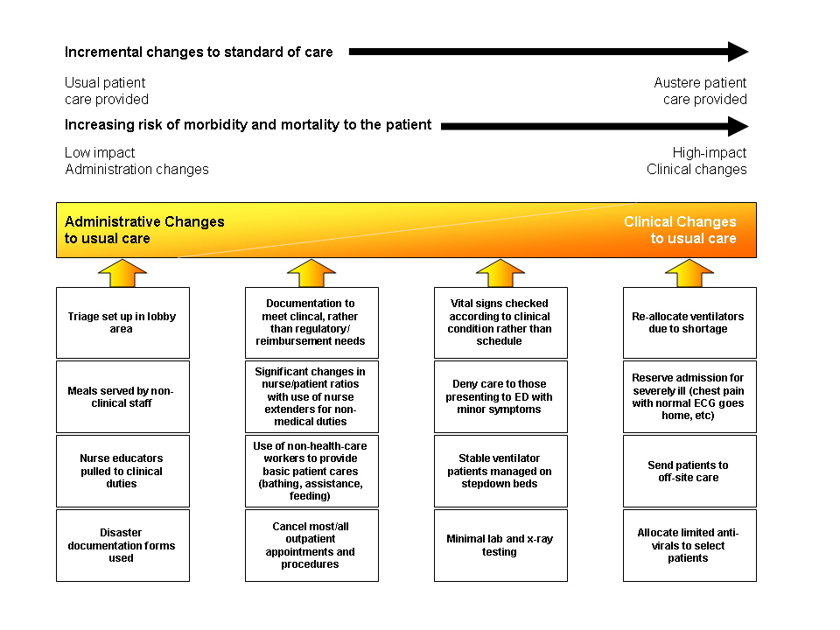

Process for Implementing Crisis Standards of Care and Triage
- Incident commander recognizes that systematic clinical changes and/or allocation of scarce clinical resources to those most likely to benefit is required.
- Planning chief gathers any guidelines, epidemiologic information, resource information, and regional health care facility information and schedules meeting or conference call with Incident commander and designees to clinical care committee.
- Clinical care committee is convened by Incident commander– membership may vary depending on incident and facility resources:
  - Health Care Administrator
  - Medical Director (Medical Care Director)
  - Health care attorney (if possible)
  - Infection Control (for infectious incident)
  - Infectious Disease (for infectious incident)
  - Critical care
  - Emergency medicine
  - Pediatrics
  - Nursing supervisor
  - Respiratory care supervisor
  - Chair of Ethics Committee
  - Ambulatory care (clinics)
  - Community representative (if possible)
  - Other – may include lab, radiology, bioelectronics, pharmacy, palliative care, burn staff, etc.
- Clinical care committee reviews situation, MDH guidance, and regional/state health care facility efforts and determines:
  - Methods to meet patient care needs (for example, use of non-invasive ventilation techniques, changes in medication administration techniques, use of oral medications and fluids instead of intravenous, etc.). These will generally be of limited value in correcting large demand/resource deficits, however. Use MDH scarce resource guidance (see MDH Patient Care Strategies for Scarce Resource Situations).
  - Additional changes in staff responsibilities to allow specialized staff to re-distribute workload (for example, floor nurses provide basic ICU patient care while critical care nurses oversee these nurses and their patients) or would incorporate other health care providers, lay providers, or family members to provide assistance based on their skillset.
  - Mechanism for reassessment of local and regional health care facility efforts and strategies (e.g., assignment of liaison officer and establishment of regular communications loop with state Science Advisory Team and any regional entities).
  - Mechanism to summarize recommendations and changes and circulate to all staff and patients/families (concrete guidelines are important to provide clarity and reduce decision-making based upon emotional or subjective factors).
- Committee reviews options for:
  - Location of care (triage of patients to critical care, floor care, off-site care, home based on disease severity)
  - Assignment of resources (which patients will receive resources in limited supply – ventilators, anti-toxin, etc., or which will not be offered such interventions when there are competing demands).
- Committee summarizes recommendations for care for next operational period and determines meeting and review cycles for subsequent periods (e.g.: daily meeting, twice daily conference call, etc.) assuring that regional efforts at the HCC level are integrated into facility process/timelines.
  - Incident commander approves recommendations and integration into Incident Action Plan (IAP). Section chiefs and Command Staff briefed and PIO assures communications to all staff.
  - Information is disseminated to inpatient services, outpatient services, and HCC. Daily conference calls with HCC involving critical care, infectious disease, command staff, as indicated by circumstances

Allocation/Re-allocation of Critical Care or Limited Resources
- Current inpatients, patients presenting to the health care facility, and their family members are given verbal and printed information - by the triage nurse in the ED with reinforcement by physician - explaining the situation and explaining that resources may have to be restricted or re-allocated, even once provided, in order to provide care to the most patients and those that will most benefit. A contact point (phone extension) for responding to patient/family questions and concerns should also be included, as should spiritual support contact information.
- Access controls should be implemented appropriate to the situation.
- Assure behavioral health resources and appoint palliative care unit leader if needed.
- Triage plan for each operational period:
  - Emergency department/Outpatient screening of patients (and denial of service to patients either too sick or too well to be benefited by evaluation/admission) based on current regional resources and regional/MDH guidance as well as facility resources.
  - Triage team – Two physicians from the affected discipline (usually two critical care or one critical care and one relevant specialty physician - infectious disease, burn surgeon, etc.) consider ventilator and other resource allocation decisions acting on data supplied by units/teams in concordance with MDH strategies (see appendix) and other evidence. (If ECMO is the resource in question one of the physicians should have ECMO expertise).
    - When two patients have essentially equal levels of illness/prognosis, a “first-come, first-served” policy should be used.
    - When, according to guidelines or the triage team’s clinical experience, the prognosis is not equal, the patient with a substantially more favorable prognosis shall receive the resource.
    - The triage team should ask for and receive whatever patient information is necessary to make a decision but should NOT consider subjective assessments of the quality of the patient’s life or value to society. (The treating physician should assure that the patient/family wishes to use the ventilator or other resources if they are available prior to asking the triage team for an opinion).
    - Triage team should pass recommendations to the inpatient unit leader and document decision-making on templates in the affected patient(s) charts
    - Note that in some situations health care facility staff may participate on regional triage team on rotating basis.
- The inpatient unit leader should maintain situational awareness of the facility. This individual should have access to:
  - ED and other outpatients waiting for beds (both floor and critical care units)
  - Inpatient bed status including pending transfers into/out of critical care areas.
  - Clinical status of patients by unit (i.e., improving: able to move to floor status or discharge or worsening: may require critical care or may not be eligible for continued treatment). This requires ongoing contact between the inpatient unit leader and the clinical units to assure that information is up to date and accurate so that good decisions can be made. The leader will work closely with the Triage Team to determine the best use of beds available.
- The process and rationale for resource assignment should be provided to the attending physician and family:
  - Grounds for the decision.
  - An appeals process that allows a period of time (appropriate to the intervention being allocated – for ventilators 15 minutes) for the attending physician to request re-consideration of the decision if there is new objective information available that that patient’s prognosis is more favorable than determined by the triage team.
  - The resource allocation protocol and decisions should be reviewed by the clinical care committee and additional oversight physicians at set periods (e.g. every 24-48 hours) and as needed to assure the best evidence available is being used and that the decisions and the system are operating justly.
    - Caution should be exercised for respiratory failure patients as this population may not improve for days to weeks. Expected progress should be diagnosis-dependent and not based on a standard time by which improvement would be expected.
  - A HICS Operations section supervisor (e.g. Inpatient Areas Supervisor) and the attending physician will agree on the level of care required for the patient after the allocation decision is made – floor, intermediate, or ICU.
    - In most cases all means of available support should continue to be offered aside from the resource triaged, and should the patient improve or more resources become available they may re-qualify for a resource, unless decision expected to result in a non-survivable state (e.g., ventilator re-allocation).
- Assure adequate symptom relief and comfort for all patients as possible based on the available resources.

Demobilization/Return to Conventional Care
Similar to having pre-identified trigger points to implement principles of CSC, it is important to continually assess and re-assess the situation as more resources arrive. We as a facility want to return to contingency and conventional care as quickly as possible. Hospital Incident Command will be in communication with external partners (HCC, state, federal partners) to ensure accurate information gathering about the situation and will relay pertinent information to the Clinical Care Committee, Ethics Team, and/or Triage Team.

Education, Training, and Exercise
Health care staff will be educated on this plan by the following tiers:
- Knowledge: awareness of the plan;
- Competency: the ability to do something successfully or efficiently in relationship to the plan; and
- Proficiency: a high degree of competence or expertise.
A list of which staff positions are trained to which level can be found in Appendix A.
Concepts of CSC will be incorporated into annual exercises as appropriate to include involvement from the Click or tap here to enter text..

Review, Authorities, References
Approval date:
Modification date(s):
Authorizing signature:

Appendix A: Education Tiers by Staff Position

Knowledge
- Hospital Executives, not in an incident command role
- Nursing staff
- Respiratory staff
- Security staff
- Click or tap here to enter text.
- Click or tap here to enter text.

Competency
- Unit Medical Directors
- Nursing Supervisors
- Respiratory Therapist Supervisors
- Click or tap here to enter text.
- Click or tap here to enter text.

Proficient
- Hospital Emergency Manager
- All staff (three deep) in incident command roles. This includes:
  - Incident Commander: Click or tap here to enter text.
  - Planning Chief: Click or tap here to enter text.
  - Operations Chief: Click or tap here to enter text.
  - Logistics Chief: Click or tap here to enter text.
  - Finance: Click or tap here to enter text.
  - Communications: Click or tap here to enter text.
- Members of the Facility Ethics Board, Triage Team, and/or Clinical Care Committee
  - Click or tap here to enter text.
  - Click or tap here to enter text.
  - Click or tap here to enter text.

Altered Standards of Care in a Mass Casualty Event (Current as of April 2005), Retrieved from Agency for Healthcare Research and Quality, Available at Appendix A, Expert Meeting on Mass Casualty Medical Care Participant List.
This may be done at a system or facility level. Please reference the Minnesota Crisis Standards of Care Framework: Health Care Facility Surge Operations and Crisis Care for more guidance.

