Nuclear Detonation Exercise in a Box for HCCs
Situation Manual
[Insert Date Here]

This Situation Manual (SitMan) provides exercise participants with all the necessary tools for their roles in the exercise. Some exercise material is intended for the exclusive use of exercise planners, facilitators, and evaluators, but players may view other materials that are necessary to their performance. All exercise participants may view the SitMan.

Exercise Overview
Exercise Name | Nuclear Exercise in a Box
Exercise Dates | [Insert date and time here]
Scope | This exercise is a tabletop exercise, planned for [#] hours at the [location]. Exercise play is limited to [insert participants here].
Mission Area(s) | Response
HPP Capabilities | Capability 2: Health Care and Medical Response Coordination  - Objective 1: Develop and Coordinate Health Care Organization and Health Care Coalition Response Plans  - Objective 3: Coordinate Response Strategy, Resources, and Communications  Capability 3: Continuity of Health Care Service Delivery  - Objective 3: Maintain Access to Non-Personnel Resources during an Emergency  - Objective 5: Protect Responders’ Safety and Health  - Objective 6: Plan for and Coordinate Health Care Evacuations and Relocation  Capability 4: Medical Surge  - Objective 1: Plan for a Medical Surge  - Objective 2: Respond to a Medical Surge
Objectives | - Review existing radiation emergency care assets and identify gaps that may occur during a radiological mass casualty incident.  - Review agency/facility role during a radiological emergency incident.  - Identify changes that need to be made in the HCC Radiation Emergency Surge Annex based on the roles and capabilities of the involved partners.
Threat or Hazard | Nuclear/Radiological – detonation
Scenario | A 20 kt surface nuclear detonation occurred, the attack has affected a 15-mile radius from the detonation. This radius does not include the fallout zones, only the damage zones from the detonation. Please go to your region’s appendix for your specific scenario.  Appendix A: Central: St. Cloud Hospital  Appendix B: Metro: U.S. Bank Stadium  Appendix C: Northeast: Canal Park/Lift Bridge/Port  Appendix D: Northwest: University of Grand Forks in North Dakota  Appendix E: Southcentral: Mankato State University  Appendix F: Southeast: Mayo Hospital in Rochester, MN  Appendix G: Southwest: Sioux Falls Avera McKennan Hospital  Appendix H: West Central: North Dakota State University in Fargo North Dakota  [Jurisdiction name] has requested assistance from the Health Care Coalitions, Minnesota Department of Health, and federal entities.
Sponsor | [Insert jurisdiction name]
Participating Organizations | See Appendix A for a complete list of participants.
Point of Contact | [Insert name, title, organization, and contact information]

General Information

Exercise Objectives and HPP Capabilities
The following exercise objectives in Table 1 describe the expected outcomes for the exercise. The objectives are linked to HPP capabilities, which are distinct critical elements necessary to achieve the specific mission area(s). The objectives and aligned HPP capabilities are selected by the Exercise Planning Team.
Exercise Objective | HPP Capability
Review existing radiation emergency care assets and identify gaps that may occur during a radiological mass casualty incident. | Capability 2: Health Care and Medical Response Coordination  Objective 1: Develop and Coordinate Health Care Organization and Health Care Coalition Response Plans  Capability 4: Medical Surge  Objective 1: Plan for a Medical Surge
Review agency/facility role during a radiological emergency incident. | Capability 2: Health Care and Medical Response Coordination  Objective 1: Develop and Coordinate Health Care Organization and Health Care Coalition Response Plans
Identify changes that need to be made in the HCC Radiation Emergency Surge Annex based on the roles and capabilities of the involved partners. | Capability 2: Health Care and Medical Response Coordination  Objective 1: Develop and Coordinate Health Care Organization and Health Care Coalition Response Plans
Enter other objectives as identified by region.

Table 1. Exercise Objectives and Associated HPP Capabilities

Participant Roles and Responsibilities
The term participant encompasses many groups of people, not just those playing in the exercise. Groups of participants involved in the exercise, and their respective roles and responsibilities, are as follows:
- Players. Players are personnel who have an active role in discussing or performing their regular roles and responsibilities during the exercise. Players discuss or initiate actions in response to the simulated emergency.
- Observers. Observers do not directly participate in the exercise. However, they may support the development of player responses to the situation during the discussion by asking relevant questions or providing subject matter expertise.
- Facilitators. Facilitators provide situation updates and moderate discussions. They also provide additional information or resolve questions as required. Key Exercise Planning Team members also may assist with facilitation as subject matter experts (SMEs) during the exercise.
- Evaluators. Evaluators are assigned to observe and document certain objectives during the exercise. Their primary role is to document player discussions, including how and if those discussions conform to plans, polices, and procedures.

Exercise Structure
This exercise will be a multimedia, facilitated exercise. Players will participate in the following three modules:
- Module 1: Initial Recognition and Response
- Module 2: Community Coordination and Collaboration
Module 3: Ongoing Healthcare Response

Module One provides a scenario background that leads exercise participants to walk through the act of a nuclear detonation, and the next steps in handling the after affects. Participants will review the situation and engage in discussion using the series of questions provided.
In Module Two exercise participants will discuss issues of stakeholder information sharing during an MCM incident. Participants will review the situation and engage in discussion using the series of questions provided.
In Module Three exercise participants will focus on healthcare surge response, in the days after the nuclear detonation. Participants will review the situation and engage in discussion using the series of questions provided.

Exercise Guidelines
- This exercise will be held in an open, low-stress, no-fault environment. Varying viewpoints, even disagreements, are expected.
- Respond to the scenario using your knowledge of current plans and capabilities (i.e., you may use only existing assets) and insights derived from your training.
- Decisions are not precedent setting and may not reflect your organization’s final position on a given issue. This exercise is an opportunity to discuss and present multiple options and possible solutions.
Issue identification is not as valuable as suggestions and recommended actions that could improve response efforts. Problem-solving efforts should be the focus.

Exercise Assumptions and Artificialities
In any exercise, assumptions and artificialities may be necessary to complete play in the time allotted and/or account for logistical limitations. Exercise participants should accept that assumptions and artificialities are inherent in any exercise and should not allow these considerations to negatively impact their participation. During this exercise, the following apply:
- There will be much more activity going on across the US and greater Minnesota in the scenario depicted in this exercise. Players will need to think of more than their jurisdiction, and how other jurisdictions are affected.
- The exercise is conducted in a no-fault learning environment wherein capabilities, plans, systems, and processes will be evaluated.
- The exercise scenario is plausible, and events occur as they are presented.
- All players receive information at the same time.

Exercise Evaluation
Evaluation of the exercise is based on the exercise objectives and aligned HPP capabilities and critical tasks which are documented in Exercise Evaluation Guides (EEGs). Evaluators have EEGs for each of their assigned areas. Additionally, players will be asked to complete participant feedback forms. These documents, coupled with facilitator observations and notes, will be used to evaluate the exercise, and compile the After-Action Report (AAR).
Module 1: INITIAL RECOGNITION AND RESPONSE

[Date and Time Here] Go to appendices for your HCC specific scenario, which includes date and time.

You are notified that a large explosion has occurred (enter area for HCC area). The location is populated by (who would be in this area based on your detonation area). Radiation detectors at the explosion site indicate higher than normal levels of gamma radiation. HAZMAT teams, specialized investigators, and environmental agencies have been dispatched to further contain and investigate the area.

Group Discussion
Based on the information provided above, and using the questions below, assign a scribe in your group and have a discussion for the next 30 minutes. Identify any critical issues, decisions, requirements, or questions that should be addressed at this time.

Module 1 Discussion Questions
- What are your initial actions upon notification of the blast? Do you know/understand your role during an emergency? Prioritize those actions.
  - What initial actions do you anticipate taking based on the location of the attack and the potential surge in emergency department and inpatient demand?
- What actions would you take once you learn that radiation detectors are going off at the explosion site?
  - Is this in accordance with coalition hospital/facility radiological response plan(s)?
  - Who in your coalition has decontamination supplies? Would they have been damaged/destroyed by the blast?
- If the HCC has an operations center, how is it activated and staffed and what functions does it serve during a radiological event?
  - How does it interface with Hospital Emergency Operations Centers (EOC)?
  - How does it interface with the Minnesota Department of Health (MDH) Department Operations Center?
- Do you know who your local, regional, and/or national facility radiological experts are and how to contact them?
- Are facility/EMS staff familiar with proper radiological screening, triage, decontamination, and treatment protocol for exposed or potentially exposed individuals?
  - Where would you obtain guidance or additional clinical advice if needed, in real time?
- What specialized resources/supplies will be needed to respond to radiological attack? What is the role of the HCC in acquiring these resources? What other radiological response resources are available within the region?
  - What detection equipment do your fire/EMS services have?
  - What detection equipment do the hospitals have?
  - What radiation response equipment does your state have and how will you request it?
  - How are SNS assets requested and received if countermeasures are needed?
  - Is there a protocol or are processes in place for resource sharing among coalition members and jurisdictional healthcare facilities?
  - If your coalition facility is destroyed, would you still have supplies, would you still have a plan?
  - What would you do if another coalition lost its facility and members?
- Who initiates information sharing for HCC members?
  - What alerts and notification mechanisms are in place to ensure that HCC members and partners are aware of the incident and can share real-time information about the disaster and plans/strategies for patient care/ transport/distribution/decontamination/supplies?
- What essential elements of information will you collect from and share with HCC members?

Notes:

Module 2: COMMUNITY COORDINATION & COLLABORATION

[Date and Time Here]
2+ hours after detonation
It is verified that a nuclear detonation occurred at (site for your coalition). The physical damage from the bombing is divided up into zones. The most extensive damage and radiation is about 1 mile around the detonation zone. The damage is less extensive the further away from the detonation zone. It will be important to model the zones to help EMS and fire/rescue. The fallout will be pushed by the wind and is going SE the day of the detonation.
The governor declares a state of emergency to support federal requests for Strategic National Stockpile (SNS) assets and additional disaster services. Major news and social media outlets are reporting that the device was nuclear detonation 911 operators and Poison Control Centers are overwhelmed with calls from people concerned about radiation exposure. Hospitals, clinics, physician offices, and other healthcare facilities in the area are beginning to receive patients and EMS transports of people who were near the site and now worried about potential exposure.

Group Discussion
Based on the information provided above, and using the questions below, assign a scribe in your group and have a discussion for the next 30 minutes. Identify any critical issues, decisions, requirements, or questions that should be addressed at this time.

Module 2 Discussion Questions
- Who has the healthcare coordination role at this point? What is it?
- Who is coordinating messaging to the public? What are the key messages to get out?
- Who has responsibility for community screening/reception centers locations for persons that are worried about contamination?
  - How will the “worried well” patients fit into community reception center (CRC) or monitoring locations?
- Who will operate the CRC?
  - How you would you get information out about CRCs?
    - Who are the partners you’re coordinating with?
  - When/how would those be coordinated, managed, supplied?
- Do facility staff understand plans for radiological contamination control and workforce safety/exposure protocols?
  - Where will PPE come from if facilities run out?
- Do the hospitals have a plan for evaluating those patients with significant radiological contamination for radiation injury and internal contamination (e.g., CBC+Diff for ALC counts and use of stool/urine monitoring)?
  - If not, who will they work with to obtain these?
  - What would you do if the public health lab was destroyed?
  - Where are stockpiles of supplies located in your region?
- What is the EMS plan for local distribution of casualties (e.g., what patients go to which hospitals if there are multiple ones receiving varying levels of trauma)?
  - What is the hospital’s capacity?
  - What are their treatment limits (e.g., not a level-1 trauma center, unable to receive high number of respiratory distress patients, specialize in burn care)?
- What special considerations affect EMS patient transportation resources during a radiological emergency (e.g., EMS restrictions related to transportation and care of radiological casualties)?
  - Where will the staging area be?
  - Is the infrastructure sound?
  - How would EMS get around rivers if bridges are destroyed?
- How will you communicate and coordinate with local law enforcement, fire, and EMS services?
  - Where is incident command set up?
  - How do you keep people safe from fallout while being triaged?
  - What do you do if you need to bring in extra EMS personal/services or EMS personal/service from a different jurisdiction?
    - How would you communicate with them?
    - How would they find their way around the city if they do not know where it is and don’t have GPS or cell phones?
- How will the community reception center (i.e., radiological screening site) be staffed?
  - Where will radiological screening equipment be sourced from?
- How will requests for chelating agents from SNS be made?
  - Where will they be delivered?
  - Who has information about local/federal stockpiles?
    - How do you communicate with them?
  - Will supplies require special storage conditions or security protocol?
  - Is there a toxicologist with experience/knowledge to determine if a chelating agent can be used?
- What agencies/contractors will the hospitals work with to address contaminated waste and low-level contamination of certain tile floors that do not respond to usual clean up procedures?
- How is the EOC Joint Information Center (JIC) coordinating public information with the HCC(s)?
  - How will you ensure clear and consistent risk communication messaging to the public and media to prevent/mitigate mass panic?
  - Are there readily available RDD information packets/scripts available for patients and staff?
- How will you address provider/public safety information needs to ensure that workers feel safe? (Note that only trivial levels of radiation have been detected outside of the cordoned area.)
- How is HCC clinical and surge information being collected and distributed (e.g., via email, special portal, messaging boards) to ensure consistent care and guidance across facilities?
  - Are special reporting requirements, metrics, or data being collected for situational awareness (e.g., hospital capacity, number exposed, transport needs, supply requests)?
  - How will the HCC coordinate and share patient information across multiple facilities for patient tracking and family re-unification?
- The physical damage from the bombing is broken into damage zones. Each damage zone has surface contamination, with higher levels at the site of the detonation.
  - Which way is the fallout going?
  - Does it affect EMS transportation, community reception centers, or decontamination facilities?
- Hospitals, clinics, physician offices, and other healthcare facilities in the area are beginning to receive patients and EMS transports of people who were near the site and now worried about potential exposure.
  - Is there decontamination equipment and radiation detection equipment in the area
  - How will you get it there if it is not, or communicate where it is?
  - If you need to help another jurisdiction, how would you get equipment to them?

Module 3: ONGOING HEALTHCARE COORDINATION

[Date and Time Here]
16-24 hours after detonation has occurred:
The number of new patients presenting to hospitals and calling 911 for evaluation of radiation exposure has increased dramatically as word spreads about the radiologic fallout/contamination. Federal agencies have been supporting the initial effort to contain and decontaminate the affected areas, however ongoing efforts to stabilize structures and close off impacted sites will be long-term with many residents remaining displaced. Many state and federal agencies including SNS are providing the necessary supplies and resources for screening, radiation countermeasures, personal protection, and decontamination.
Hospitals within the HCC are operating over capacity. Hospital staff, concerned over exposure, are calling in sick. There is confusion about the thresholds for referring an exposed person for countermeasure treatment (which, due to the limited number of persons that need it, is being given through the hospitals). Overall, workforce across the region is being impacted. Mental health and wellness experts are warning of negative mental health issues among those affected by the bombing, the public, and healthcare workers. The medical examiner is asking for assistance with protocols and decontamination of decedents. As clean-up is ongoing, waste management and proper disposal of contaminated materials is becoming difficult.
A community reception center is operating to help conduct radiological screening of those worried about exposure. Residents have been asked to bag the clothing they were wearing, shower, and present to the site with their bag for evaluation—if they were inside of the area defined by the current cordon—though many others are presenting for evaluation. Surveillance and long-term follow-up on transported patients and those presenting to the hospitals and the community reception center are difficult to track.

Group Discussion
Based on the information provided above, and using the questions below, assign a scribe in your group and have a discussion for the next 30 minutes. Identify any critical issues, decisions, requirements, or questions that should be addressed at this time.

Module 3 Discussion Questions
- How will the Community Reception Centers handle the influx of patients?
  - What are the key roles and responsibilities of greeters? What training and resources will be important?
  - What are the critical considerations for serving clients with access and functional needs? What training and resources will be important?
  - How will you manage flow of clients who arrive at the CRC in the following situations?
    - How will you handle screening and information for individuals?
    - Paper, electronically?
- How does the HCC Radiological Emergency Surge Annex address community radiological screening?
- Does the HCC have a coordination role at this point?
  - What is it? If not, who is coordinating healthcare resource issues?
- How will the HCC, or coordination lead, work towards resupplying or redistributing needed equipment and supplies?
  - How will it ensure proper supply levels are continuously available if response efforts take longer than anticipated?
- What types of staffing shortages will occur for long-term response needs (e.g., over weeks) and how can the HCC help to address them?
  - How many hospital staff, especially in the ER have been REAC/TS trained?
- How will you address radiological waste issues; what agencies, partners can support exponential increased need for collection and disposal of contaminated materials?
- How will the HCC coordinate with the Federal Bureau of Investigation to retain possible evidence from radiologically contaminated clothing?
  - Where will evidence be stored?
  - How will it be monitored to ensure it does not reach a hazardous level?
- How are patients being tracked that were transported or who may need follow-up care, ongoing treatment?
  - Does the tracking mechanism support family reunification efforts?
- What is the process for providing ongoing situational awareness communication among the HCC facilities, or jurisdictional health facilities, regarding capacity, transported patients, updated treatment guidelines?
- What is your communication strategy to alleviate public fear and misinformation?
  - How are mental health services being offered to incident survivors and the workforce?
- How is information being tracked/documented for an after-action report (e.g., issues, gaps, lessons learned)?
- What efforts can be made to divert concerned but not exposed residents to seek medical attention at facilities other than hospital settings?

Notes:

Next Steps/ Assignments (Hot Wash):
Discuss the following questions immediately after the exercise and take notes to inform your After-Action Report:
- Which processes need additional work to be operational?

- Which partners do we need to do more work to coordinate with?

- Which trainings need to be given in advance? Which just-in-time training materials are needed?

- What information isn’t in the MDH guidance that you still need?

- What are the action steps to address the issues you’ve identified? Who is responsible for each action step?

Other notes:

Appendix A: Central, St. Cloud Hospital
A 20 kt nuclear detonation just occurred at St. Cloud Hospital, at 8:00am. It is unclear if it was a surface or airburst explosion, but assumed to be a surface detonation, which means there will be radioactive fallout. The average number of people in the area at the time is being reported at 40,000 people and it’s expected that up to 60,000 people have been injured or exposed to radiation.
Current weather has winds at SE at 15 mph, if the model holds true, some of the fallout is expected to pass over downtown Minneapolis. The fallout is going to follow highway 10 down to Minneapolis and Saint Paul, meaning highway 10 will be closed. St. Cloud hospital is unable to be used, and the St. Cloud VA hospital will need to be closed for the next 24 hours to assess damage and determine if it can reopen.
MNDOT has assessed the bridges crossing the Mississippi River in St. Cloud and determined the 3rd street bridge and the University bridge are not structurally sound and will be closed for the time being.
The coalitions will need to coordinate with each other to get the best care possible to the numerous patients who have been affected by the nuclear detonation. Many patients will have trauma or burn injuries, as well as dealing with acute radiation syndrome (ARS) patients. It is possible ARS patients will continue to arrive at the hospital emergency department 24-48 hours after the initial event and surge.
Minnesota Radiation Injury Treatment Network Hospitals
o University of Minnesota
o Mayo Clinic Rochester
Many patients (approximately 70%) will require diagnostic monitoring to determine the level of Acute Radiation Syndrome which may be managed at an outpatient site.
Only 10% of the total casualties from the detonation of an IND will have radiation only injuries and therefore be appropriate for RITN centers.
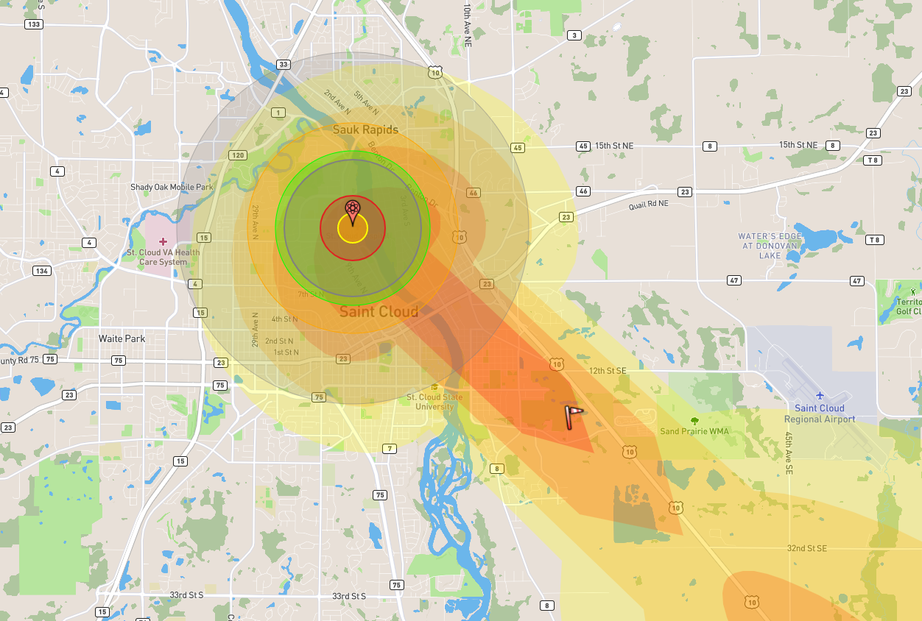
Appendix B: Metro, U.S. Bank Stadium
A 20 kt nuclear detonation just occurred at U.S. Bank Stadium, at 2:00pm, before the football game which starts at 3:25pm. It is unclear if it was a surface or airburst explosion, but assumed to be a surface detonation, which means there will be radioactive fallout. Game time attendance is being reported at 60,000 people today and it’s expected that up to 100,000 people have been injured or exposed to radiation.
Current weather has winds at NE at 15 mph headed towards Northern St. Paul. This means none of the Saint Paul area hospitals have been affected by the detonation, or the fallout zones. However, the detonation has destroyed HCMC, and left significant damage at both University of Minnesota Hospitals, Abbott Northwestern, and Minneapolis Children’s. These hospitals are locked down, sheltering in place, and dealing with internal injuries that will need to be transported while the hospital is assessed for functionality. All Minneapolis hospitals will be unable to accept or transfer patients for at least 48 hours.
MNDOT has assessed the bridges crossing the Mississippi River in Minneapolis and all are sound except for the I-94 bridge. I-94 is closed in both directions between highway 280, and N Lowery Ave in Minneapolis. MNDOT has also assessed Highway 35W, and all bridges are sound, however the highway is closed from NE Stinson Blvd to 36th Street.
The Metro Coalition staff offices have been destroyed, but luckily with the Vikings game being on a Sunday afternoon, the coalition members were at home. Until the Metro coalition can get together, the Minnesota Department of Health with be the primary point of contact. Many patients will have trauma or burn injuries, as well as dealing with acute radiation syndrome (ARS) patients. It is possible ARS patients will continue to arrive at the hospital emergency department 24-48 hours after the initial event and surge.
Minnesota Radiation Injury Treatment Network Hospitals
  - University of Minnesota
  - Mayo Clinic Rochester
Many patients (approximately 70%) will require diagnostic monitoring to determine the level of Acute Radiation Syndrome which may be managed at an outpatient site.
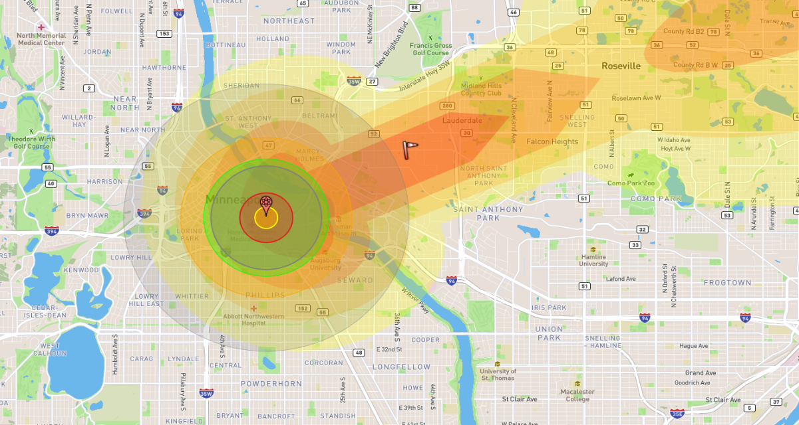
Only 10% of the total casualties from the detonation of an IND will have radiation only injuries and therefore be appropriate for RITN centers.

Appendix C: Northeast, DECC
A 20 kt nuclear detonation just occurred at the DECC during a UMD hockey game, around 8:00pm, It is unclear if it was a surface or airburst explosion, but assumed to be a surface detonation, which means there will be radioactive fallout. Population numbers are being reported on average around 50,000 people today and it’s expected that up to 20,000 people have been injured or exposed to radiation.
Current weather has winds at SE at 15 mph headed towards Wisconsin. This means the Saint Paul and Minneapolis hospitals are not affected by the fallout zones. However, the detonation has damaged both St. Luke’s, and Essentia in Duluth. These hospitals are locked down, sheltering in place, and dealing with internal injuries that will need to be transported and the hospital is assessed for functionality. All Duluth hospitals will be unable to accept or transfer patients for at least 48 hours.
MNDOT has assessed Highway 35 in and out of Duluth. Highway 35 is closed in both directions between N 19th Ave. E and N 40th Ave. W. MNDOT has also assessed Highway 35W, and all bridges are sound in the Duluth area, but the Lift ridge was destroyed.
There will need to be lots of communication and collaboration with the other HCCs in the state. Many patients will have trauma or burn injuries, as well as dealing with acute radiation syndrome (ARS) patients. It is possible ARS patients will continue to arrive at the hospital emergency department 24-48 hours after the initial event and surge.
Minnesota Radiation Injury Treatment Network Hospitals
  - University of Minnesota
  - Mayo Clinic Rochester
Many patients (approximately 70%) will require diagnostic monitoring to determine the level of Acute Radiation Syndrome which may be managed at an outpatient site.
Only 10% of the total casualties from the detonation of an IND will have radiation only injuries and therefore be appropriate for RITN centers.
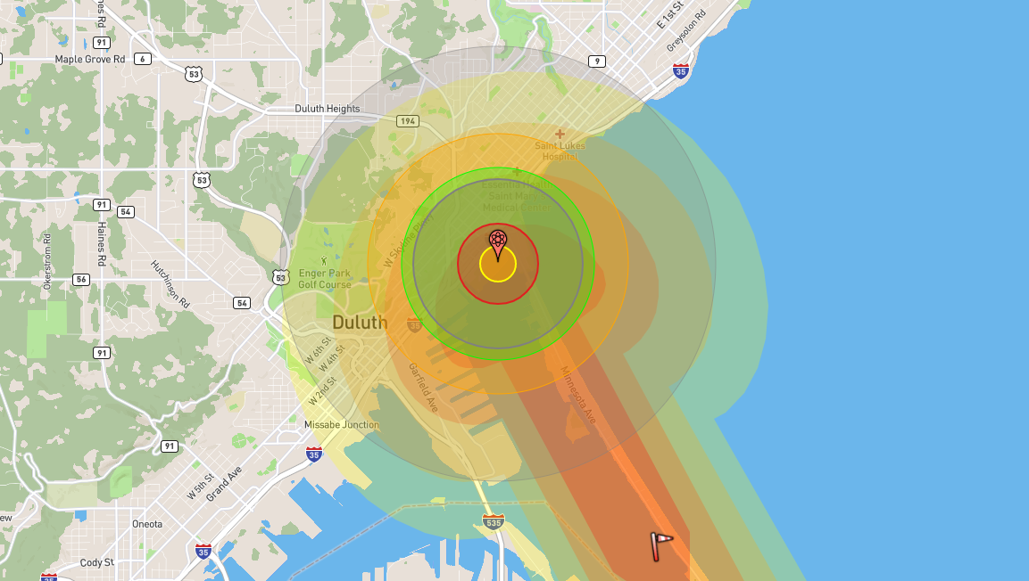
Appendix D: Northwest, University of North Dakota.
A 20 kt nuclear detonation just occurred at The University of North Dakota. It is unclear if it was a surface or airburst explosion, but assumed to be a surface detonation, which means there will be radioactive fallout. Population numbers are being reported on average around 50,000 people today and it’s expected that up to 20,000 people have been injured or exposed to radiation.
Current weather has winds at SE at 15 mph headed towards Ada, Minnesota. Due to the location of the nuclear detonation, the Grand Forks hospital was significantly damaged. The hospital is closed, and evacuations are underway for the patients/staff that survived. Many people will need to be transported out of Grand Forks and brought to Fargo or the Twin Cities.
MNDOT has assessed the bridges crossing the Red River and all are sound. Due to the detonation, Highway 29 in North Dakota is closed in both directions between 32nd Ave. S. and Gateway Drive.
The Northwest Coalition will need to be in communication with the North Dakota Incident Commander, and with the other HCCs in the state. The NW HCC will need to collaborate and coordinate to help transfer and treat patients throughout the state of MN. Many patients will have trauma or burn injuries, as well as dealing with acute radiation syndrome (ARS) patients. It is possible ARS patients will continue to arrive at the hospital emergency department 24-48 hours after the initial event and surge.
Minnesota Radiation Injury Treatment Network Hospitals
  - University of Minnesota
  - Mayo Clinic Rochester
Many patients (approximately 70%) will require diagnostic monitoring to determine the level of Acute Radiation Syndrome which may be managed at an outpatient site.
Only 10% of the total casualties from the detonation of an IND will have radiation only injuries and therefore be appropriate for RITN centers.
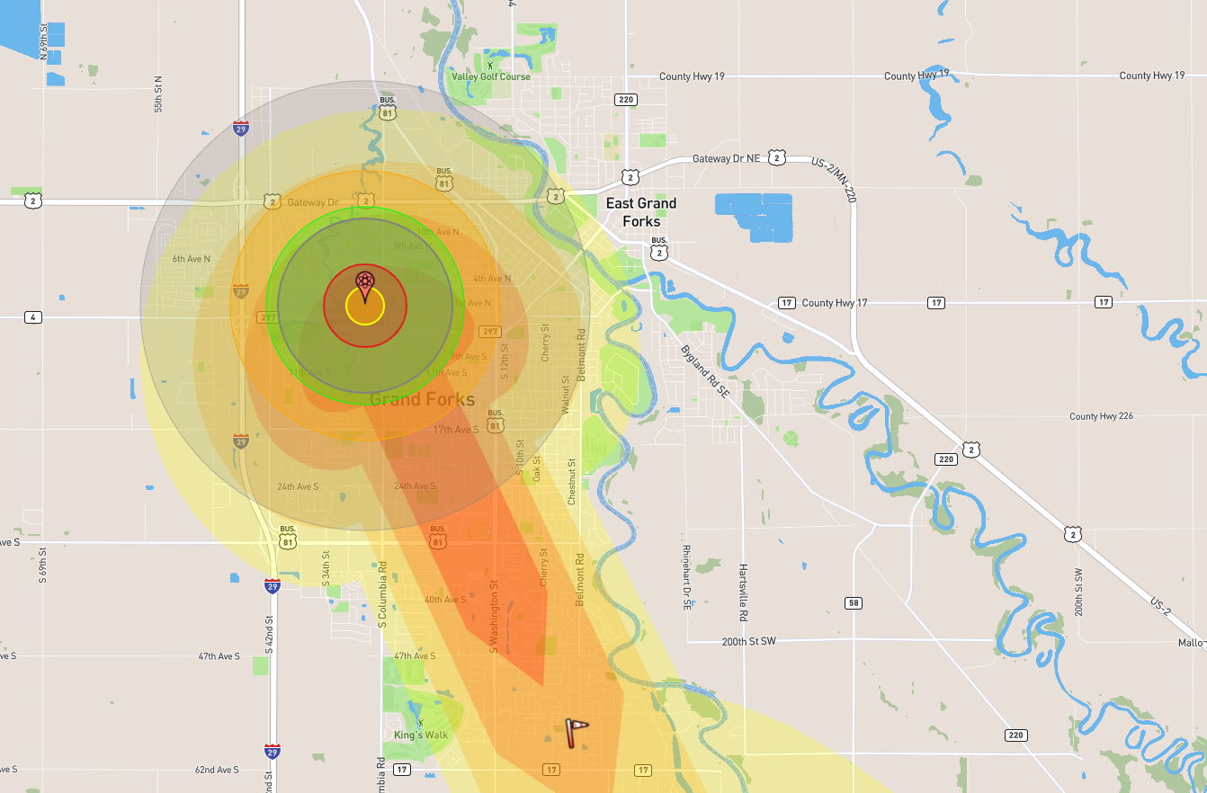
Appendix E: South Central, Mankato State University
A 20 kt nuclear detonation just occurred at Mankato State University, at 8:00am. It is unclear if it was a surface or airburst explosion, but assumed to be a surface detonation, which means there will be radioactive fallout. Population numbers on average are being reported at around 40,000 people today and it’s expected that up to 20,000 people have been injured or exposed to radiation.
Current weather has winds at SE at 15 mph headed Highway 90. This means Highway 90 will be closed in both directions between County Highway 22, and Alden, MN. The detonation has damaged the Mayo Clinic Health System Hospital in Mankato. The hospital is locked down, sheltering in place, and dealing with internal injuries that will need to be transported while the hospital is assessed for functionality. It is expected to be closed for 48 hours.
MNDOT has assessed the bridges crossing the Minnesota River in Mankato and all are sound except for the Highway 169 bridges. Highway 169 is closed in both directions between Monroe Ave, and Country Road 71.
Many patients will have trauma or burn injuries, as well as dealing with acute radiation syndrome (ARS) patients. It is possible ARS patients will continue to arrive at the hospital emergency department 24-48 hours after the initial event and surge.
Minnesota Radiation Injury Treatment Network Hospitals
  - University of Minnesota
  - Mayo Clinic Rochester
Many patients (approximately 70%) will require diagnostic monitoring to determine the level of Acute Radiation Syndrome which may be managed at an outpatient site.
Only 10% of the total casualties from the detonation of an IND will have radiation only injuries and therefore be appropriate for RITN centers.
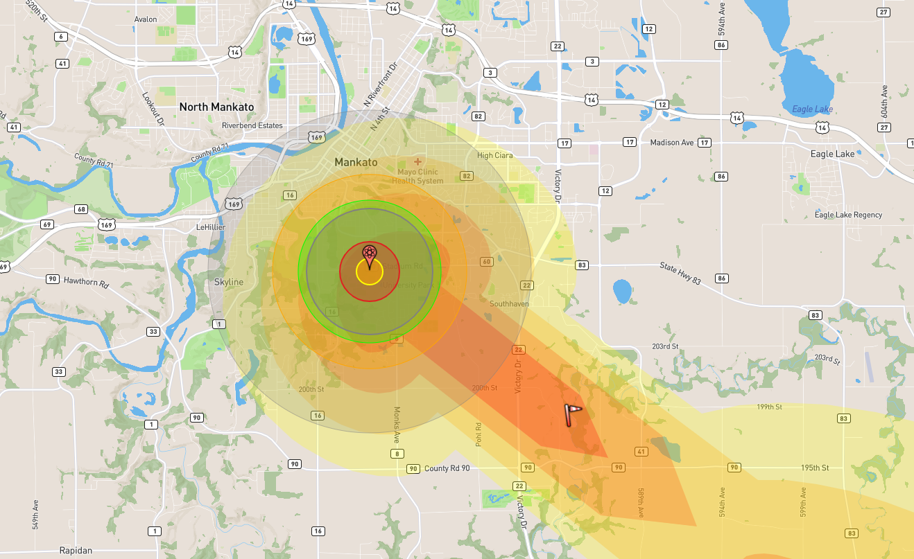
Appendix F: Southeast, Mayo Hospital, Rochester
A 20 kt nuclear detonation just occurred The Mayo Clinic Hospital in Rochester, at 2:00pm. It is unclear if it was a surface or airburst explosion, but assumed to be a surface detonation, which means there will be radioactive fallout. Game time attendance is being reported at 60,000 people today and it’s expected that up to 100,000 people have been injured or exposed to radiation.
Current weather has winds at SE at 15 mph, heading towards highway 90, which could disrupt traffic flow. Unfortunately, the detonation has destroyed The Mayo Clinic campus, and has left significant damage at Saint Mary’s, Federal Medical Center, and Olmsted Medical Center. These hospitals are locked down, sheltering in place, and dealing with internal injuries that will need to be transported while the hospital is assessed for functionality. All hospitals in lock down will be unable to accept or transfer patients for at least 48 hours.
MNDOT has assessed the highways in Rochester. MN Highway 52 is closed in both directions between 37th St. NW, and the junction of MN highways 52 and 63 in the southern area of Rochester.
The Southeast Coalition staff offices have been destroyed. With these offices destroyed, the other HCCs in the state will need to help communicate and collaborate during the response. Many patients will have trauma or burn injuries, as well as dealing with acute radiation syndrome (ARS) patients. It is possible ARS patients will continue to arrive at the hospital emergency department 24-48 hours after the initial event and surge.
Minnesota Radiation Injury Treatment Network Hospitals
  - University of Minnesota
  - Mayo Clinic Rochester – taken out in detonation.
Many patients (approximately 70%) will require diagnostic monitoring to determine the level of Acute Radiation Syndrome which may be managed at an outpatient site.
Only 10% of the total casualties from the detonation of an IND will have radiation only injuries and therefore be appropriate for RITN centers.
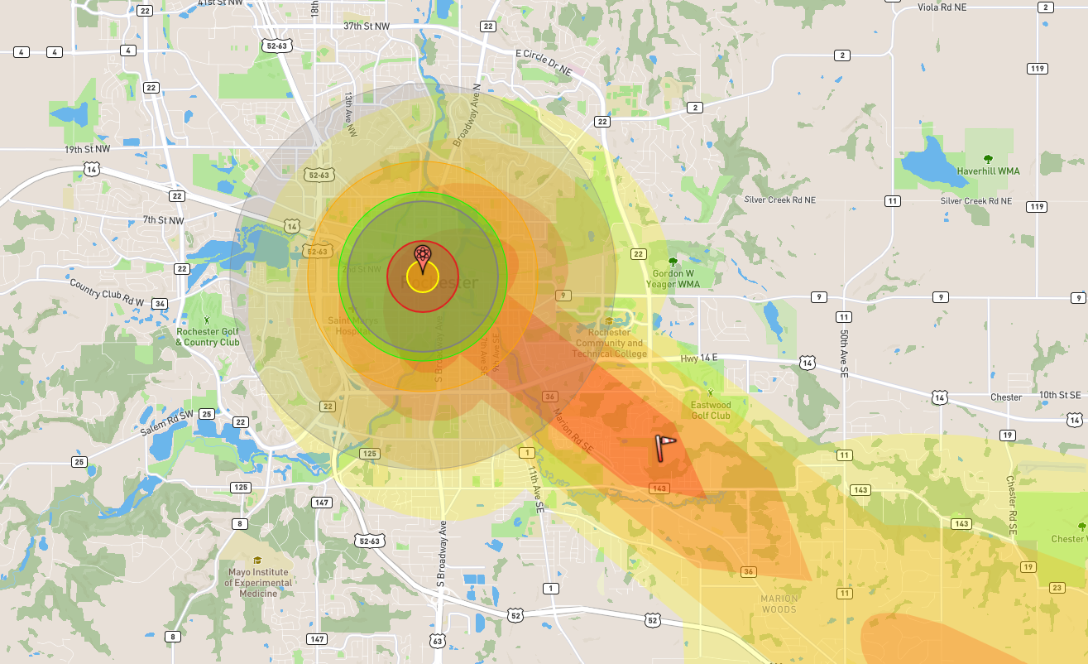
Appendix G: Southwest, Sioux Falls Avera McKennan Hospital
A 20 kt nuclear detonation just occurred at the Sioux Falls Avera McKennan Hospital. It is unclear if it was a surface or airburst explosion, but assumed to be a surface detonation, which means there will be radioactive fallout. Attendance is being reported at 60,000 people today and it’s expected that up to 30,000 people have been injured or exposed to radiation.
Current weather has winds at SE at 15 mph, this does not affect any hospitals outside the blast zone, or the State of Minnesota. Unfortunately, Sanford USD Medical Center was in the light blast zone. This hospital is locked down, sheltering in place, and dealing with internal injuries that will need to be transported while the hospital is assessed for functionality. It is unknown how long they will be closed for.
Roads have been assessed, and Highway 229 has been affected. Highway 229 is closed between E 57th Street, and E Rice Street, or local highway 140. The blast was set off at the RITN center in South Dakota, which means the burden will fall on MN to take as many RITN eligible patients as we can.
The Sioux Falls Department of Health has asked for help from the State of Minnesota. The Southwest Healthcare coalition will need to communicate with both Sioux Falls authorities and other MN coalitions to help transfer patients to treat them. Many patients will have trauma or burn injuries, as well as dealing with acute radiation syndrome (ARS) patients.
Minnesota Radiation Injury Treatment Network Hospitals
  - University of Minnesota
  - Mayo Clinic Rochester
Many patients (approximately 70%) will require diagnostic monitoring to determine the level of Acute Radiation Syndrome which may be managed at an outpatient site.
Only 10% of the total casualties from the detonation of an IND will have radiation only injuries and therefore be appropriate for RITN centers.
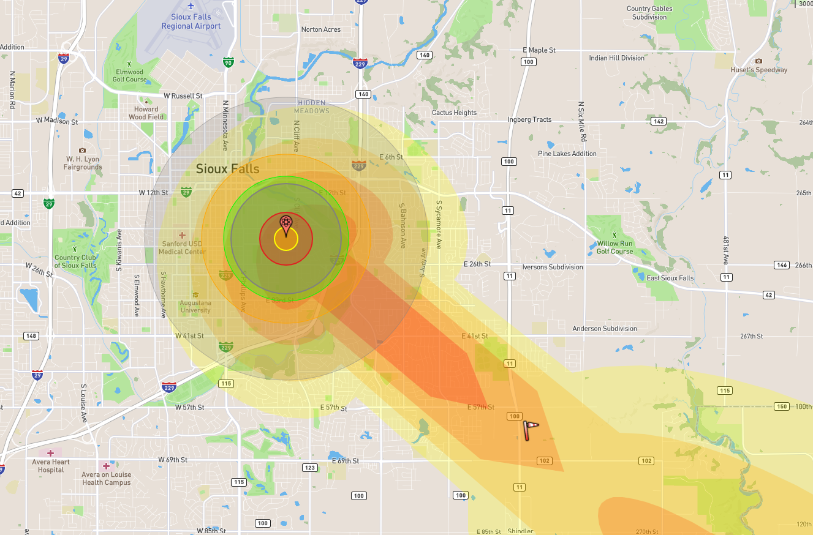
Appendix H: West Central, West Acres Shopping Center
A 20 kt nuclear detonation just occurred at West Acres Mall on Saturday, at 2: 00pm. It is unclear if it was a surface or airburst explosion, but assumed to be a surface detonation, which means there will be radioactive fallout. Average attendance in the area is around 20,000 people and it’s expected that up to 50,000 people have been injured or exposed to radiation.
Current weather has winds at SE at 15 mph, luckily the wind, as of now is not affecting Highway 94 in Minnesota. Due to the location of the blast, Sandford Hospital and Essentia Hospital were in the light blast zone. These hospitals are locked down, sheltering in place, and dealing with internal patients that will need to be transferred and transported while the hospital is assessed for functionality. These hospitals will be unable to accept patients for the first 24 hours after the blast.
Roads and bridges have been assessed the bridges crossing the Red River are all sound. I-94 is closed in both directions between S University Drive, and 9th Street East. Highway 29 is also closed between 12th Ave. N, and 40th Ave. S., until damage can be further assessed.
The Fargo Department of Health has asked for help from the State of Minnesota. The West Central Healthcare coalition will need to communicate with both Fargo authorities and other MN coalitions to help transfer patients and get them care. Many patients will have trauma or burn injuries, as well as dealing with acute radiation syndrome (ARS) patients.
Minnesota Radiation Injury Treatment Network Hospitals
  - University of Minnesota
  - Mayo Clinic Rochester
Many patients (approximately 70%) will require diagnostic monitoring to determine the level of Acute Radiation Syndrome which may be managed at an outpatient site.
Only 10% of the total casualties from the detonation of an IND will have radiation only injuries and therefore be appropriate for RITN centers.
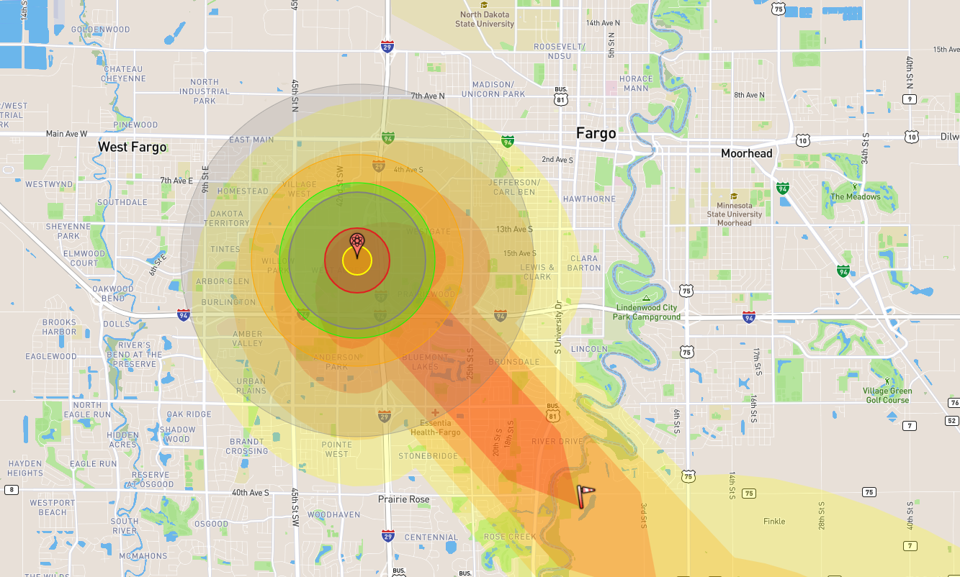
Appendix I: Exercise Participants
Participating Organizations

Appendix J: Acronym List
Acronym | Definition
AAR | After Action Report
AAR-IP | After Action Report-Improvement Plan
ASPR | Office of the Assistant Secretary for Preparedness and Response
CDC | Centers for Disease Control and Prevention
CRC | Community reception center
ED | Emergency Department
EMS | Emergency Medical Services
HPP | Hospital Preparedness Program
HSEEP | Homeland Security Exercise and Evaluation Program
POC | Point of Contact
PPE | Personal Protective Equipment
PUI | Person Under Investigation
SitMan | Situation Manual
SME | Subject matter expert
TTX | Tabletop exercise

Appendix K: Participant Feedback Form

Name (optional): _______________________________________

Facilities represented: ______________________________________

Participant Recommendations and Corrective Actions
- Based on your facility actions and your opinions (not the results of the hotwash), list the top three strengths you identified.

- Based on your facility actions and your opinions (not the results of the hotwash), list the top areas you identified that need improvement.
The information you provide in this document will be used to inform the After-Action Report and After-Action Conference.
Overall program rating:
- Excellent
- Above average
- Average
- Fair
- Poor
Please provide any recommendations on how this exercise or future exercises could be improved and/or enhanced.

