Be prepared for an opioid overdose emergency.

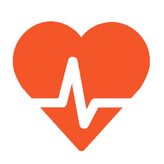
Naloxone is a medication that temporarily blocks the effects of an opioid during an opioid overdose. Naloxone can save lives.
GET TRAINED
You are invited to attend a naloxone training session at no charge, which includes naloxone kits. See the schedule of upcoming public naloxone training sessions at steverummlerhopenetwork.org or call 952-943-3937.
FOR MORE INFORMATION:
WWW.HEALTH.STATE.MN.US/OPIOIDDASHBOARD

