Minnesota Department of Health



# National Nutrition Month® – March 2024

WIC SOcial media toolkit

**For use only by WIC and Local Public Health Agencies in Minnesota**

For questions, please contact:

Minnesota Department of Health  
WIC Program  
PO Box 64882  
St. Paul, MN 55164-0882  
651-201-4404   
[health.wic@state.mn.us](mailto:health.wic@state.mn.us)  
[www.health.state.mn.us](http://www.health.state.mn.us/)

Contents

National Nutrition Month® – March 2024 1

How to Use This Toolkit 3

What is a “social media toolkit?” 3

Guidance for local agencies 3

Creating posts 3

Responding to comments on your posts 4

Social media ideas for March 4

Messages 5

Nutrition messages 5

Other Ideas 8

Spotlight on nutrition staff 8

Pictures 8

Using the photos 8

MDH WIC Photos 9

USDA Photos 12

NWA Campaign Photos 12

National Nutrition Month® Graphics 15

## How to Use This Toolkit

### What is a “social media toolkit?”

WIC mission is to safeguard the health of low-income women, infants, and chidlren up to age 5 who are at nutrition risk by providing nutritious foods, information on healthy eating, and referrals to health care. This toolkit was designed to make it easy for WIC local agencies to pick a message and photo to post without taking time and resources away from clinic operations. This will also help maximize WIC social media presence, sharing important information with current and potential participants. Local WIC, or local public health agencies, have the opportunity to engage with WIC participants and eligible families in a more relevant and personalized way than the Minnesota Department of Health. This toolkit provides messages and pictures to support social media efforts promoting nutrition. These messages are consistent with MDH’s position, and the pictures are designated for WIC and WIC partner use.

### Guidance for local agencies

MN WIC follows the [Academy of Nutrition and Dietetics (https://www.eatright.org/about-national-nutrition-month)](https://www.eatright.org/about-national-nutrition-month)) (AND) theme for National Nutrition Month®, “Beyond the Table.” The theme address the farm-to-fork aspect of nutrition, describes the various way we eat, and keeps sustainability in mind. During the month of March, everyone is invited to learn about making informed food choices and developing healthful eating and physical activity habits.

Select and post any of the content in this toolkit to your agency’s social media pages. You can also use these as a starting point to create your own posts. Consider posting twice a week to keep your followers engaged. You do not need to use all the posts.

You are encouraged to use your own pictures, as long as you have a signed release form giving your agency permission. If you don’t have your own pictures to use, you can select and use images or video links in this toolkit. Please do not edit the MDH pictures.

### Creating posts

* Keep posts short. About three sentences is a good length.
* Include a link, pointing to a website to learn more about the topic. If you’re including a link in an Instagram post, add the link to your profile and the text, “Link in profile” to your post.
* Include the “#MNWIC” hashtag and other relevant hashtags.
  + This makes our posts more visible statewide. Hashtags connect similar conversations, so they are seen by anyone searching for the hashtag.
  + Other hashtags: #NationalNutritionMonth, #RDNday, #NDTRday, #NNMchat, #eatright, #eatrightPRO, #kidseatright. You can also make your own hashtag for your agency.
* Make sure your photos are clear, well-lit, and match the post.
* Use plain language so your followers understand your message.
* You must use your agency photos in Instagram posts. This social media platform requires users to post photos they took or have the rights to post. You cannot use generic website photos or MDH photos on this social media platform.
* YouTube videos make great Facebook posts. Include a couple sentences addressing the video’s main message and add the YouTube video link. Don’t include a photo because the video preview will show in the post. Select shorter videos to hold your followers’ interest.
* You can pay to “boost” posts so they show up in more newsfeeds. Typically, a user only sees a post if they follow the page, or if one of their friends interacts with the post. Boosting a post displays the post to social media users who meet specified criteria. There are more requirements for posts you choose to boost, and your agency may need to spend time monitoring the post and responding to comments. If you have questions about boosting posts, contact Megan Leonard at [megan.leonard@state.mn.us](mailto:megan.leonard@state.mn.us).

### Responding to comments on your posts

Interacting with your followers is part of the benefits of social media. Take time to answer questions and respond to comments. This will help you reach more people using your social channels.

Unfortunately, unfriendly or biased comments are a part of social media. MDH Communications suggests responding to complaints in a neutral, understanding manner. Be as open as possible and follow your agency’s or county’s social media guidelines.

You should try to respond to comments the same day they are posted. Certain comments don’t need a response, or other Facebook users may provide an adequate response for you. If you need help formulating a response to a question or comment, contact Megan Leonard at [megan.leonard@state.mn.us](mailto:megan.leonard@state.mn.us) for assistance.

### Social media ideas for March

MDH WIC will post Facebook and Instagram content during National Nutrition Month® on our social media channels. Watch the [Minnesota WIC on Facebook](https://www.facebook.com/MNWIC) and [Minnesota WIC on Instagram](https://www.instagram.com/minnesotawic/) pages throughout the month to interact with and share our posts.

Consider posting additional social media content throughout National Nutrition Month®. AND lists key dates for social media posts and dates:

* **March 1 - 31**

Celebrate National Nutrition Month ® throughout March!

* **March 4 at noon Central Time**

Join @eatright for a chat to kick off National Nutrition Month®! Join on X using the hashtag #NNMchat to talk nutrition and healthful eating.

* **March 13**

Celebreate Registered Dietitian Nutritionist Day. Show appreiation to RDNs who make a positive impact on lives through their expertise and dedication. #RDNday.

* **March 14**

Celebrate Nutrition and Dietetics Technician, Registered Day. Recognize NDTRs for their work to promote wellness and create a healthier future for families. #NDTRday.

## Messages

These posts are designed for Facebook, since most Minnesota local agencies use that platform. X limits posts to 280 characters (links take up 23 of those characters). Instagram posts should only use original pictures taken by your local agency.

* AND has a social media toolkit available for partners to use: [National Nutrition Month® https:/socialpresskit.com/nnm2024](https://socialpresskit.com/nnm2024))
* Check out [50 Ideas to get involved in National Nutrition Month®(https://www.eatright.org/health/wellness/awareness-campaigns/50-ideas-to-get-involved-in-national-nutrition-month)](https://www.eatright.org/health/wellness/awareness-campaigns/50-ideas-to-get-involved-in-national-nutrition-month).

### Nutrition messages

#### Messages to celebrate National Nutrition Month® during March:

Take a message and coordinate it with one of the photos in this kit for an easy social media post.

**Resources from AND to promote National Nutrition Month:**

* **Weekly key messaging**
  + Week One: Stay nourished on any budget.
    - Learn cooking, food preparation and meal planning skills.
    - Use a grocery lists and shop sales when purchasing food.
    - Learn about community resources such as SNAP, WIC, and local food banks.
    - Practice home food safety.
  + Week Two: See a Registered Dietitian Nutritionist (RDN).
    - Ask your doctor for a referral to an RDN.
    - Find an RDN who specializes in your unique needs.
    - Receive personalized nutrition information to meet your health goals.
    - Learn about the many ways RNDs can help people live healthier lives.
  + Week Three: Eat a variety of foods from all food groups.
    - Include your favorite cultural foods and traditions.
    - Eat foods in various forms including fresh, frozen, canned, and dried.
    - Experiment with recipes using different ingredients.
    - Try new foods or global cuisines.
  + Week Four: Eat with the environment in mind.
    - Get creative with leftovers and ways to reduce food waste.
    - Enjoy more plant-based meals and snacks.
    - Buy foods in season and from local farmers when possible.
    - Grow food at home or in community garden.

Visit [National Nutrition Month® Resources (https://www.eatright.org/national-nutrition-month/resources](https://www.eatright.org/national-nutrition-month/resources)) for tip sheets, activity handouts, and additional information about this campaign!

#### National WIC Association messages:

* Persistence: Try again
  + #feedingfact Your child may need to see a new food 10 times before they try it. So if they reject something at first, keep trying. “No” today may be “yes” tomorrow…or next week. #persistence
* WIC Food: Yogurt
  + Yogurt is loaded with protein, calcium, potassium, and healthy bacteria called probiotics. That’s why it’s part of the WIC food package. Ask your WIC nutritionist for easy and delicious ways to serve yogurt.
* Bravo Parents!
  + Bravo, parents! [clap emoji] Participating in WIC helps boost kids’ nutrition, immunization rates, and readiness for kindergarten. #gettingitdone #WIC
* Tiny Stomach
  + Your baby’s stomach is tiny—about the size of their fist—so it doesn’t hold a lot of breast/chest milk. That’s why baby needs to feed often, about 8 to 12 times a day.
* Toddler Appetites
  + Worried that your toddler seems to eat a lot one day and almost nothing the next? It’s totally normal. Toddler appetites change from day to day. Just keep offering healthy food and respect their ability to know if they are hungry or full. Ask your local WIC staff if you have any questions.
* Ready for Solids?
  + Is your baby ready for solid food? Wait until your baby is around 6 months old and can sit up with some help, hold their head steady, and eat food from a spoon and swallow it.
* Veggies Early and Often
  + Did you know that introducing your baby to veggies as soon as they start eating solid foods can help baby like them? Just make sure they’re pureed or well-cooked and mashed. And be patient: It can take 10 or more tastes for a child to accept a new food!
* Beans
  + Warm up with a hearty bowl of chili or bean soup tonight! Beans are packed with fiber, protein, folate, iron, and more. And they’re super versatile. If your kids don’t like chili or soup, try bean burritos, bean dip, or black bean burgers. #coolbeans
* Little Helper
  + Ask your child to help you food shop! They can choose the best-looking vegetables, search for a specific cereal, or count out four red apples. #makeitfun
* Eat the Rainbow
  + Put your additional WIC benefits for fruits and vegetables to good use! Different colors signal different nutrients, so choose a rainbow of produce to get a variety of vitamins and minerals in your family’s diet. #eattherainbow
* Role Model
  + **Your child’s #1 role model? You! Your child learns a lot just by watching you—so that’s even more of a reason to eat nutritious foods, get physical activity, make healthy choices, and be kind to others.**
* Family Meals
  + Did you know family meals can help your child’s health and happiness? The reason: eating together can teach smart food choices, prevent excessive weight gain, and improve social-emotional health. Breakfast counts, too!
* National Nutrition Month®
  + Happy National Nutrition Month! Need ideas for healthy meals? Looking for new ways to use your WIC foods? Wondering how to feed a picky eater? Our nutritionists can help!

## Other Ideas

If you want to go above and beyond a traditional post, here are some more advanced ideas for social media posts. Some of these options require a little more time but boost engagement.

### Spotlight on nutrition staff

* Provide a quick bio (with photo) of one of the staff in your agency to talk about the work they do and how they help families in your area.
* Possible topics:
  + Give some background about how they came to work for WIC.
  + If applicable, they can share their experience feeding their children.
  + Share information about why they values WIC and how WIC helps parents and caregivers raise healthy families.

## Pictures

These photos are available for the Minnesota WIC program and its local agencies to use. Email [health.wic@state.mn.us](mailto:health.wic@state.mn.us) if you have questions regarding photo usage outside of your local agency.

### Using the photos

* Right click the photo you want to use and select “save as.”
* Save the photo to your desktop or other location.
* When you open the saved photo it will display in its original size and quality. Do not alter the pictures. Do not use these photos for Instagram posts.

### MDH WIC Photos

Onions
 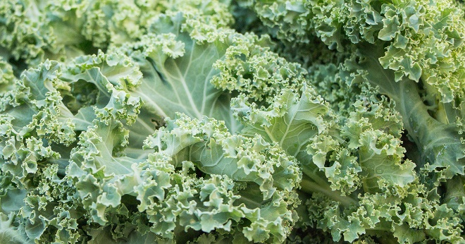

cauliflower
 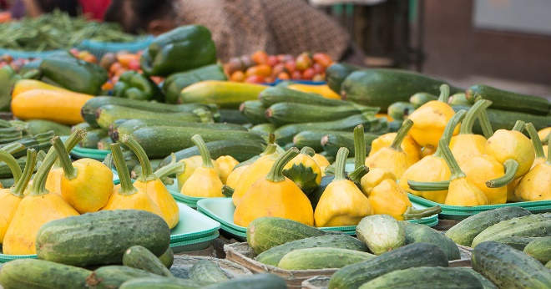

tomatoes sliced
 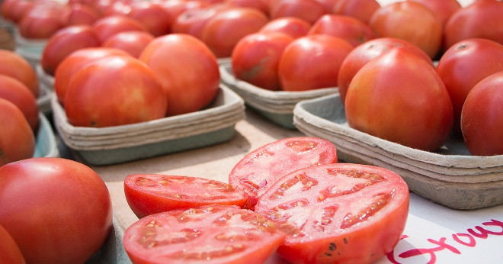

farmers market vegetables
 tomatoes


woman weighing bananas at grocery store
 bananas


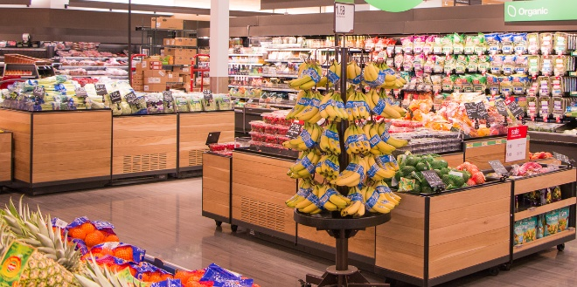 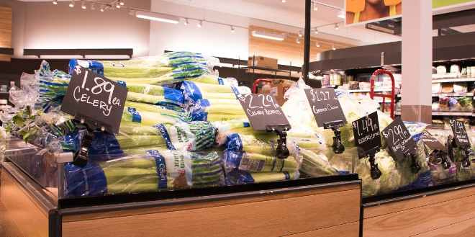

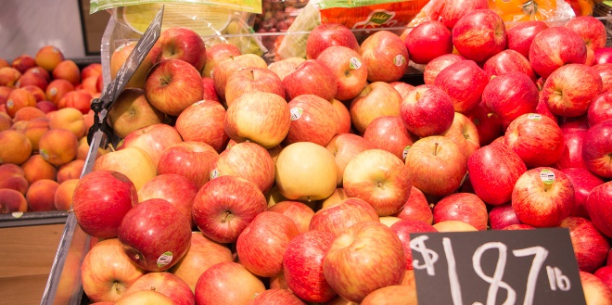 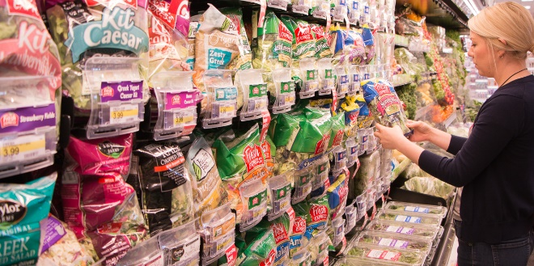

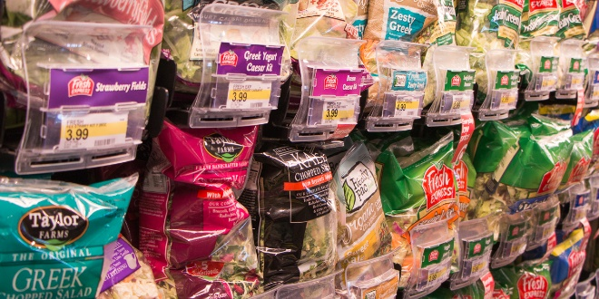 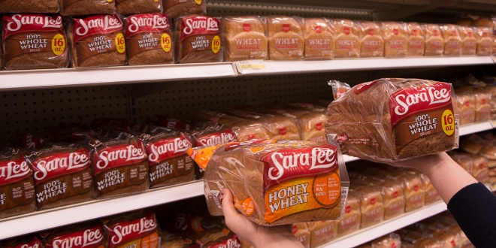

w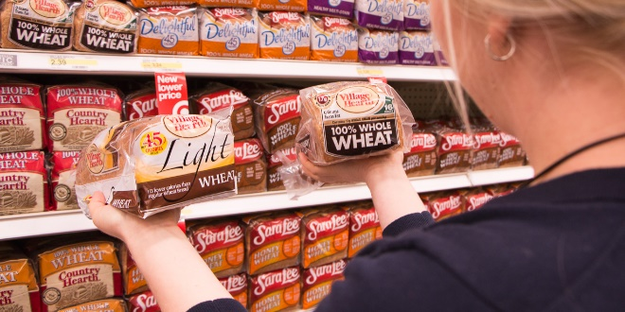 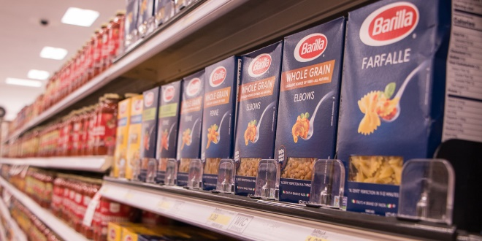

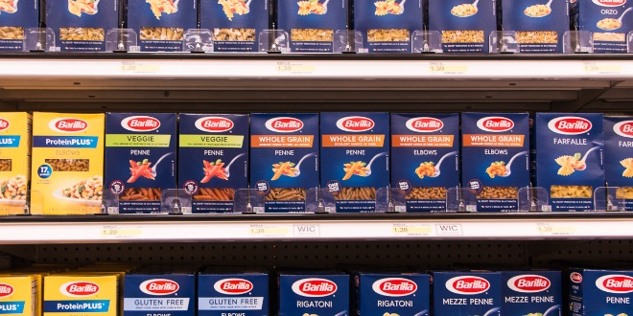 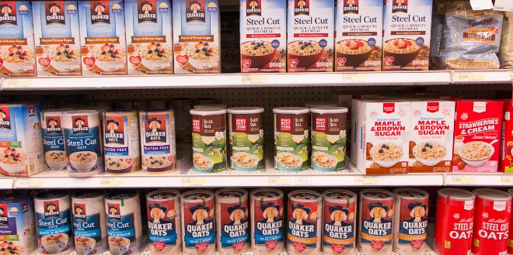

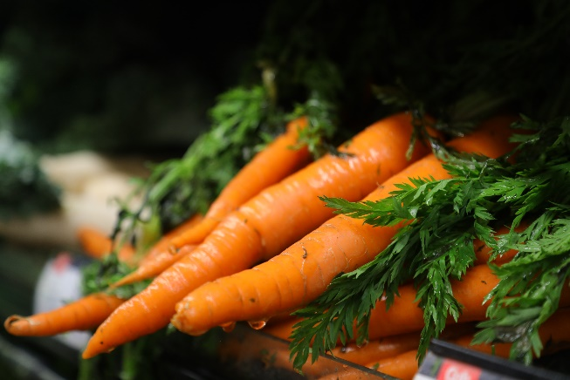 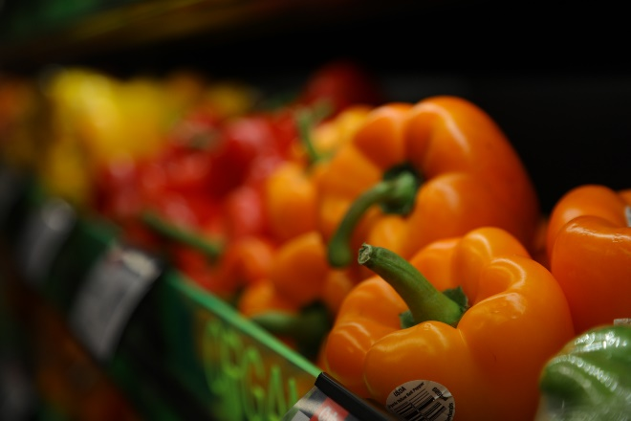

 

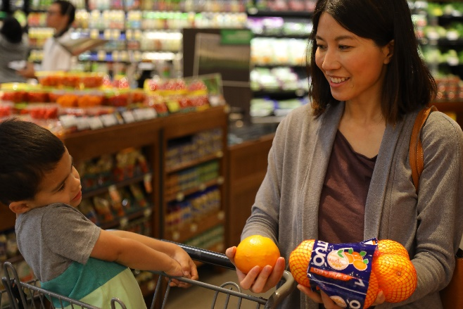 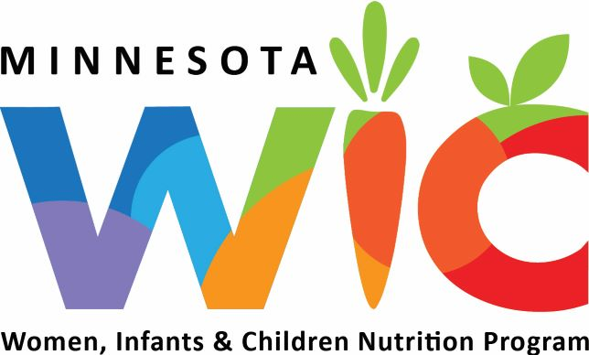

### USDA Photos

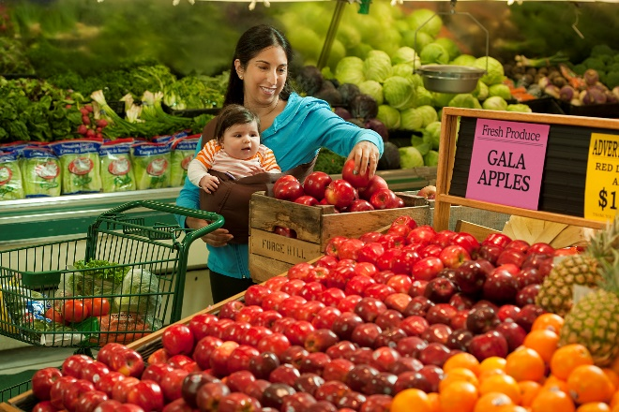 

### NWA Campaign Photos

 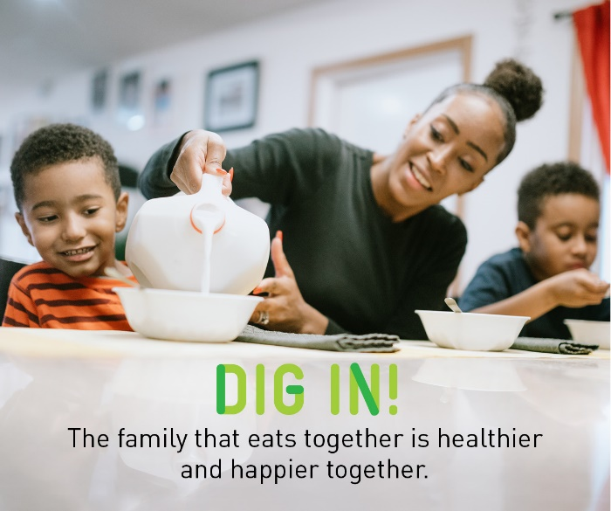

 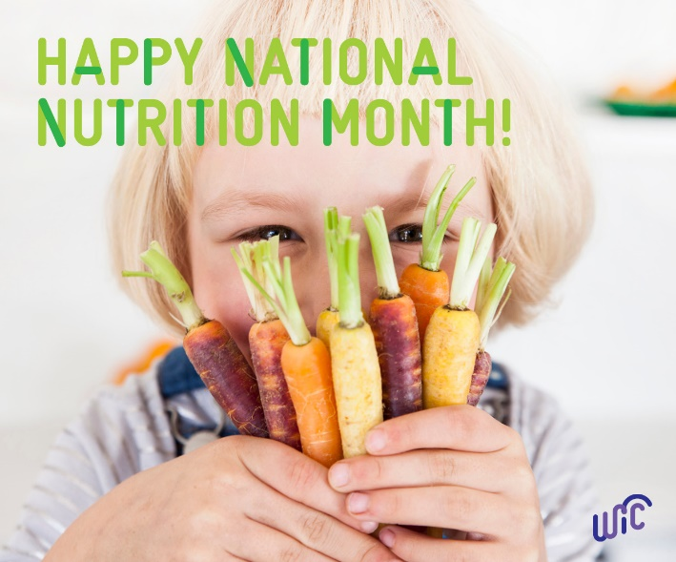

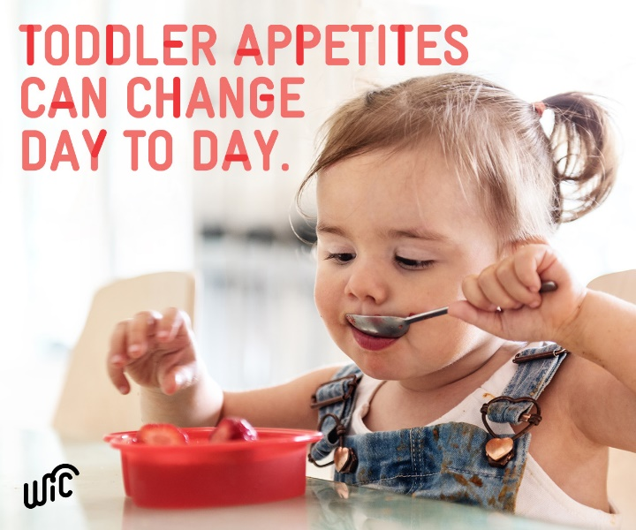

 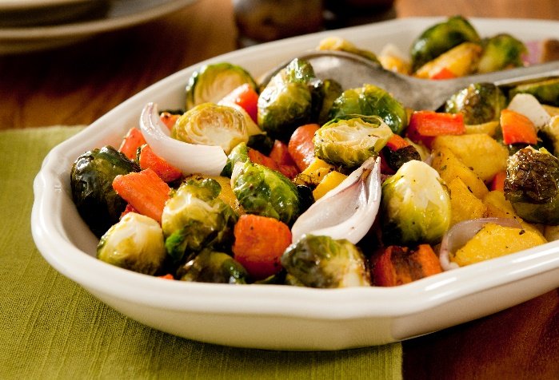

 

 

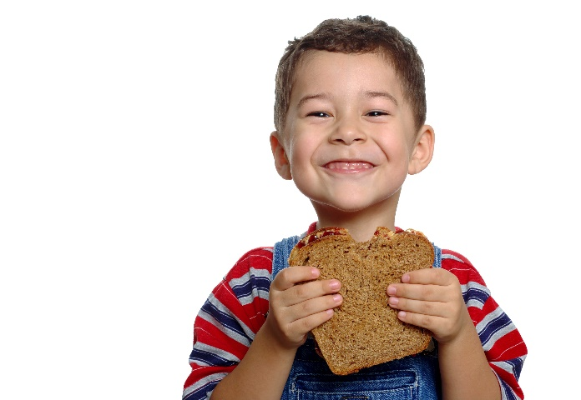 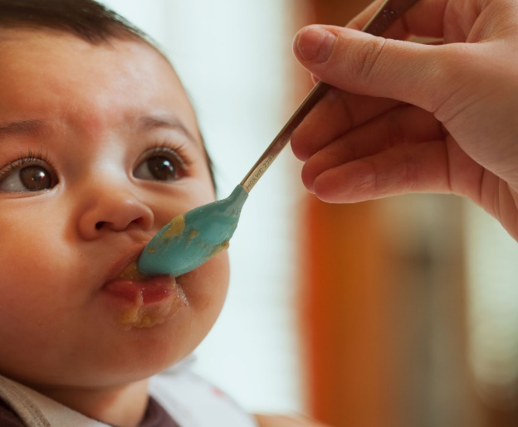

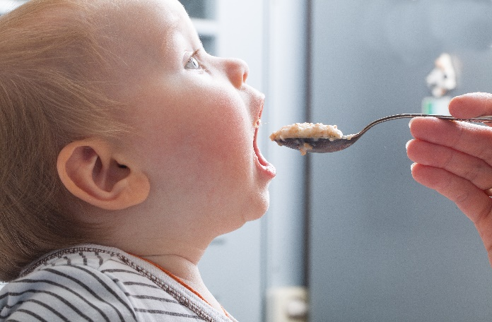 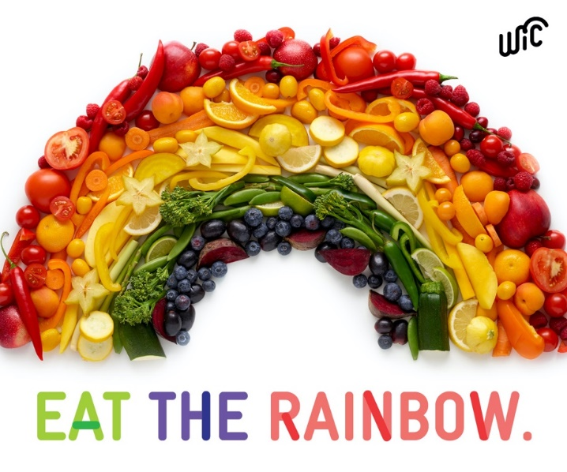

### National Nutrition Month® Graphics

