Anthropometrics Guidebook
  - UPDATED OCTOBER 2022
Preceptor Edition

This guidebook was adapted from a training created by the Arizona WIC program.

Contents
Contents 2
What Will You Learn? 3
Items Needed for This Course 3
Recommended Time 3
Things to Remember 3
Anthropometrics Course Instructions 4
Important Notes About This Module 4
Module 1: Anthropometrics 5
Module 1 Competencies: 5
Module 1: Activity 1 6
Module 1: Activity 2 9
Module 1: Activity 3 10
Module 1: Activity 4 10
Module 1: Activity 5 12
Module 2: Practicing BMI and Interpreting Growth Charts 14
Module 2 Competencies: 14
Module 2: Activity 1 15
Module 2: Activity 2 16
References- A Complete Listing of Hyperlinks: 20

What Will You Learn?
Measuring length (or height) and weight is a simple and effective way to identify healthy growth patterns or to detect potential concerns for WIC participants. Accurate measures of length, height, and weight provide key information needed for a full nutrition assessment. Assessing growth and weight is an important step for helping WIC counselors determine if a participant has potential health risks.
After completing the Anthropometrics Module and this associated guidebook, you will be able to:
- Demonstrate proper techniques for taking accurate and precise measurements (Module 1)
- Avoid common errors when taking measurements (Module 1)
- Interpret and explain anthropometric charts to participants (Module 2)

Items Needed for This Course
- Pen or pencil
- Local Agency Referral List
- Access to Anthropometrics Module
- Access to the Anthropometric Manual Minnesota WIC Program
- Access to the MN WIC Exhibit 4-H: Checklist for Certification Observations
- Access to the MN Allowed WIC Risk Criteria

Recommended Time
- Approximate time it takes to complete the Anthropometrics LMS Course: One to two hours.
- Approximate time it takes to complete the activities in this Anthropometrics Guidebook and discuss with your preceptor: One to two hours.

Things to Remember
- This guidebook is yours to keep.
- You are encouraged to take notes, highlight, and write in this guidebook.
- As your preceptor chooses, you may work in a group or as an individual.
- Your preceptor has the answers to the questions posed in this guidebook.
- You are encouraged to ask your preceptor for help, ask questions about the information in the Anthropometrics Module, or ask any questions about additional topics related to anthropometrics.

PRECEPTOR NOTE: As the preceptor, you are assessing trainees’ understanding of the Anthropometrics competencies for each module. The guidebook training activities are intended to help you assess both trainees’ ability to apply basic knowledge and their critical thinking skills.
Participation by trainees in the face-to-face activities and discussions is required in order for you to thoroughly assess their skills and level of competence.

Anthropometrics Course Instructions
- Locate the Anthropometrics Module on the MN WIC New Staff Training Page.
Open and complete the Anthropometric module and the corresponding activities in this guidebook.
At your preceptor’s direction, complete the Anthropometrics Module and guidebook, either individually, with other trainees, or with your preceptor.
Complete the Anthropometrics Post-test located on the MN WIC New Staff Training Page.
Meet with your preceptor at their direction to discuss each module of the Anthropometrics training and the associated activities in this guidebook, either after each module or after all modules have been completed.
PRECEPTOR NOTE:
- At your discretion, trainees may work in groups or as individuals.
- At your discretion, you may review answers with trainees periodically as they complete guidebook activities, or after they have fully completed it.
- “Possible responses” provided throughout the guidebook are suggested responses and are often not the only answers.
- If training more than one person at a time, be prepared for trainees to finish the coursework at different times. In order to have the trainees review the face-to-face portions together, prepare a list of things the trainees who finish first can work on during downtime (e.g., ask you questions for more clarification, check email, clinic observation, etc.).

Important Notes About This Module
This Anthropometric Module was developed by the Arizona WIC Program and covers general anthropometric procedures and techniques. It provides a comprehensive review of requirements and is adequate Anthropometric Training for most MN WIC staff. For specific MN requirements and policy, refer to the Anthropometric Manual Minnesota WIC Program and Minnesota Operation Manual Section 5.3 Nutrition Risk Assessment, Section 5.3.1 Anthropometric Data. Variations between the Arizona WIC Program Anthropometric Module procedures and Minnesota WIC Program requirements are listed below.
- Minnesota WIC does NOT require second measurements. A single measurement of height/length or weight is adequate when care is taken to assure that proper measuring techniques are used. Whenever there is any doubt about the accuracy of a measurement, staff should re-measure.
- The Minnesota WIC Information System calculates Gestation-Adjusted Age for premature infants. For infants and children 0-24 months old who were born premature, the plot on the WHO graphs in the Minnesota WIC Information System correspond to their adjusted age and not their chronological age.
- For premature infants, the MN WIC Information system will show one plot on the Growth Grid, not two as stated in the module. If an infant is measured before reaching an adjusted age of 1 day, the measurement does not plot, as the graph does not allow for negative age values.
- The Minnesota WIC Information System has “Premature Len/Age and Premature WT/Age grids. It is not recommended to use these grids to assess growth as is explained in HuBERT Clinic Training Modules- Growth & Weight Gain Grids .
- Specific anthropometric equipment requirements for the Minnesota WIC Program are described in the Anthropometric Manual Minnesota WIC Program.
- Minnesota WIC does not use Multi-Fetal Prenatal Weight Gain Grids, only Singleton Pregnancy girds are used. The CPA should take weight gain recommendations for multi-fetal pregnancies into consideration as they review the Prenatal Weight Gain Grid in the Minnesota WIC Information System.

Module 1: Anthropometrics
PRECEPTOR NOTE: It is recommended for you to review the competencies below with trainees.

Module 1 Competencies:
- Trainees will be able to describe appropriate techniques for accurate measurement of length and weight for infants.
- Trainees will be able to offer guidance that helps participants prepare infants to be ready for measurement.
- Trainees will be able to guide the participant in steps to maintain the infant's comfort and position until accurate measurements are obtained.
- Trainees will be able to describe all of the steps necessary to accurately obtain length and weight measurements for infants.
- Trainees will be able to identify solutions for typical challenges when measuring infants (e.g., no spare diaper, tantrums, distractions, etc.).
- Trainees will be able to describe all of the steps and techniques necessary to accurately obtain standing height and weight measurements for children and adults.
- Trainees will be able to demonstrate accurate height and weight measurement of children
and adults.
- Trainees will be able to identify common measurement errors for infants, children, and adults.

Module 1: Activity 1
PRECEPTOR NOTE: Allow the trainee time to read through the following activity and answer all questions. Discuss the questions together to check for understanding and consider other appropriate responses.
Instructions: For each question below, a descriptive term for collecting anthropometric data as listed in the MN WIC Exhibit 4-H: Checklist for Certification Observations is given. Answer the questions below by explaining the meaning for each term and how it affects measurement accuracy.
- Anthropometrics Tool: Scale is zero balanced between weights.
- What is meant by this phrase?
Possible responses:
• Ensuring the scale is reset to zero when no weight it added. Zeroing the scale removes any previous measurement.
- How would not zeroing the scale affect the new measurements?
Possible responses:
• It may add weight into the new measurement, resulting in an inaccurate weight.
[Reference: Anthropometric Manual, Measuring Weight, Technique]
- Anthropometrics Tool: Both Shoes and heavy clothing removed.
- What is meant by this phrase?
Possible responses:
• Ensure that shoes or boots and heavy clothing such as a bulky sweater, coat, or snow pants have been removed.
- How would shoes and heavy clothing affect the weight? How about the height?
Possible responses:
• Wearing clothing while weighing a participant can add up to two pounds, more if they are wearing shoes or boots.
• Wearing shoes while measuring height/length can add up to a 1/2 inch the measurement.
[Reference: Anthropometric Manual, Measuring Weight, Technique]
- Anthropometrics Tool: Legs and hips straight, head facing up, both legs are used.
- What is meant by this phrase?
Possible responses:
• Child should be placed flat on their back with head facing towards the ceiling, and both legs fully extended.
- How does pulling down only one leg or not straightening the legs affect length measurements?
Possible responses:
• It is important that both legs be fully extended for an accurate measurement. If only one leg is extended, the measurement will likely be inaccurate.
[Reference: Anthropometrics Manual, Measuring Length, Technique]
NOTE: Study finds that measuring length in newborns using only one leg results in significantly longer measurements. [Precision of recumbent crown-heel length when using an infantometer; BMC Pediatrics, November 14, 2016.]
- Anthropometrics Tool: Hats, braids, and hair accessories removed.
- What is meant by this phrase?
Possible responses:
• Remove any object on top of the head that may interfere with collecting an accurate measurement. The top of the head should be touching the headboard.
- How is length measurement affected when infants wear large hair accessories?
Possible responses:
• Any accessory on top of the head can add incremental length to the measurement.
[Reference: Anthropometrics Manual, Measuring Length, Technique]
- Anthropometrics Tool: Clean, dry diaper, and t-shirt.
- What is meant by this phrase?
Possible responses:
• The child should be wearing only a clean/dry diaper and a t-shirt when placed on the scale.
- How do soiled diapers affect weight measurement?
Possible responses:
• A soiled diaper will add weight to the measurement. A wet diaper can add up to 2 pounds!
[Reference: Anthropometric Manual, Measuring Weight, Technique]
- Anthropometrics Tool: Participant positioned properly on the equipment.
- What is meant by this phrase?
Possible responses:
• Ensuring the participant is positioned properly while on the scale to measure weight or when using the board to measure for length or height.
- How would an improper position affect the final measurements.
Possible responses:
• It may be difficult to get an accurate measurement if the participant is not properly positioned leading to an incorrect assessment, education, and counseling.
[Reference: Anthropometrics Manual, Measuring Height/Weight, Technique]
- What type of infant scale will you use in your clinic? (Circle one)
- Infant balance beam scale
- Infant electronic scale
Possible responses: (Varies by clinic)
- Infant balance beam scale
- Infant electronic scale
[Reference Module 1, Slide 5]
- Describe the difference between accuracy and precision in measuring.
Possible responses:
- Precision is the ability of a measurement to be consistently repeated over and over. In other words, how close your measurements are to one another.
- Accuracy is the ability of the measurement to match the actual value of the quantity being measured.
[Reference Module 1, Slide 7]
- What would alert you to an incorrect weight measurement?
Possible responses:
- If the measurement is not consistent with previous measurements taken.
- If the measurement looks like it may be wrong.
[Reference: Anthropometrics Manual, Common Measurement Errors]
NOTE: If the value is incorrectly read, rounded, or recorded, incorrect assessments may be made, leading to inappropriate risk codes, and nutrition education.
- What would alert you to an incorrect length measurement?
Possible responses:
- If the measurement is not consistent with previous measurements taken.
- If the measurement looks like it may be wrong.
[Reference: Anthropometrics Manual, Common Measurement Errors]
NOTE: If the value is incorrectly read, rounded, or recorded, incorrect assessments may be made, leading to inappropriate risk codes, and nutrition education.
- Describe when recumbent length is still used with children up to 36 months old.
Correct response:
- Children 24-36 months who cannot stand unassisted or measure <30 inches must be measured lying down.
[Reference Module 1, Slide 20]
PRECEPTOR NOTE: The Anthropometrics Course states, "Some computer systems auto-default to recumbent length for children 36 months and younger." The course says “Some computer systems…” because other WIC state agencies share this training course. For AZ WIC, HANDS computer system auto-defaults to standing height and weight for children 24 months of age and older.
NOTE: MN WIC Information System auto-defaults to standing height and weight for children 24 months of age and older.

Module 1: Activity 2
PRECEPTOR NOTE: Allow the trainee time to read through the following activity and answer all questions. Discuss the questions together to check for understanding and consider other appropriate responses.
Instructions: For each scenario below, offer an example of what you might say to help a participant understand what happens next.
- A participant is holding her baby and waiting for your instructions to weigh her infant.
Possible responses:
- Next, we’ll get your baby’s weight. Please place her on the scale and try to keep her comfortable while I record her weight.
- A participant is holding her baby and waiting for your instructions to measure her infant’s length.
Possible responses:
- Next, we’ll measure your baby’s length. Can you please place her on the length board and hold her head still against the top of the board, facing the ceiling? I’ll get her legs and body aligned to get an accurate length as quickly as possible. If she gets too upset to cooperate, we can stop and try again later.

Module 1: Activity 3
PRECEPTOR NOTE: Allow the trainee time to read through the following activity and answer all questions. Discuss the questions together to check for understanding and consider other appropriate responses.
Instructions: For each question below, write out the best solution for the situation.
- A participant tells you they do not have a clean diaper to replace the infant’s wet diaper at the certification appointment.
Possible responses:
- Offer participant a clean diaper (if your clinic offers diapers for these situations).
- Record weight information using the medical provider’s documentation (if measurement was taken within 60 days).
- Infant is flailing wildly so that weight cannot be measured.
Possible responses:
- Weigh caregiver while holding infant, and then take another measurement of the caregiver’s weight without infant. To determine the infant’s weight, subtract the caregiver’s weight from the caregiver’s and infant’s combined weight.
- Allow infant to calm down and attempt to take measurement later in the appointment.
- Record weight information using the medical provider’s documentation (if measurement was taken within 60 days).
- If necessary, offer to reschedule the certification appointment, since weight is a requirement for certifications.

Module 1: Activity 4
PRECEPTOR NOTE: Allow the trainee time to read through the following activity and answer all questions. Discuss the questions together to check for understanding and consider other appropriate responses.
Instructions: For each question, write out the best solution for the situation.
- Which of the following child participants should be measured with height instead of recumbent length?
- A 23-month-old child who can stand with support
- A 22-month-old child who stands unassisted
- A 28-month-old child in a wheelchair who can stand with support
- None of the above
Correct response: d. none of the above
Children under 24 months old cannot be measured standing, even if they are able to stand unassisted. Children 24-36 months who cannot stand unassisted must be measured lying down.
NOTE: The growth charts for children under 2 years of age are for recumbent length only. Charts will not plot correctly with standing heights.
- Which of the following guidelines are correct for measuring children under 24 months?
- Ankles, hips, and shoulder blades aligned
- Without top hair adornment
- Without shoes
- Both legs are grasped and straightened for measurement (length)
- All of the above
Correct response: e. All of the above.
Refer to the Anthropometrics Manual for measuring children under 24 months.
- At what age do you begin measuring children’s standing height vertically?
Correct response:
- 24 months and older
[Reference Module 1, Slide 25]

- What type of scale will you use to weigh children/adults in your clinic?
- Electronic scale
- Balance beam scale
Possible responses: (Varies by clinic)
• Electronic scale
- Balance beam scale
- For weight, what is the unit of measurement that appears on the child/adult scale in your clinic?
Possible responses:
- Pounds and tenths of a pound
- Kilograms/decagrams
- Pounds/ounces
- Pounds/quarter pounds
- For the child/adult scale, what is the unit of measurement you will enter for weight? (Module 1, Slide 12)
Possible responses:
- Pounds/ounces
- Kilograms/grams
[Reference Module 1, Slide 12]
NOTE: Verify trainee understands how to enter metric measurements in the WIC Information System. For example, if documentation from a provider has weight in kilograms and grams, or a participant requests weight to be measured in kilograms instead of pounds.
- Using your clinic’s reference sheet for converting tenths of a pound to ounces, what value would you enter if you measured a child’s weight to be 26.7 lbs?
Possible responses:
- 26 lbs/11 ounces
[Reference Module 1, Slide 15]
- For the child/adult stadiometer, what is the unit of measurement you will enter for height?
Possible responses:
• Inches and eighths of an inch
• Centimeter/millimeter
[Reference Module 1, Slides 28 and 29]

Module 1: Activity 5
PRECEPTOR NOTE: Allow the trainee time to read through the following activity and answer the questions. Discuss the questions together to check for understanding and consider other appropriate responses.
Instructions: For each activity, enlist the help of your preceptor or a coworker (if possible) to help you practice taking anthropometric measurements.
  - Take a precise and accurate weight measurement of a fellow staff member (or yourself if a coworker is not available). Document this number.
Next, repeat the same measurement while wearing shoes and removable outer clothing (additional layers, if applicable). Document this number.
What is the numerical difference between the first and second weight measurements?
Answers will vary
  - Take a precise and accurate weight measurement of a fellow staff member (or yourself if a coworker is not available). Document this number.
Next, repeat the same measurement while positioning the person’s body towards the edge of the scale rather than in the center of the scale. Document this number.
What is the numerical difference between the first and second weight measurements?
Answers will vary
  - Name as many common errors as possible in measuring recumbent length.
Possible responses:
• Incorrect equipment for the age of the child
• Only one leg extended
• Shoes or hats not removed
• Both heels not firmly against board
• Feet not parallel to movable board
• Head not firmly against headboard; remove braids, barrettes, ponytails or anything that prevents board from resting against the head. If unable to do so, record in the notes section.
• Body not straight
• Head not facing ceiling
• Body or knees arched or bent
• Board not on flat surface
[Reference Module 1, Slide 23]
  - Name as many common errors as possible in measuring height for children and adults.
Possible responses:
• Incorrect equipment for the age of the child
• Shoes and hats not removed
• Feet not straight or flat on the floor
• Shoulder, buttocks, head, and heels not firmly against the backboard
• Head not firmly against headboard; remove braids, barrettes, ponytails or anything that prevents board from resting against the head. If unable to do so, record in the notes section.
• Head not held straight facing forward
• Knees bent
[Reference Module 1, Slide 30]
  - How can a height measurement of a child or woman be affected if their head moves downward so their chin is near their chest?
Possible responses:
• Moving the chin toward the chest will lower head position, resulting in a reduced height measurement.
  - How can the difference between an accurate and an inaccurate measurement potentially affect WIC data?
Possible responses:
• Inaccurate data may cause WIC codes to be assigned in error.
• Inaccurate data may prevent WIC codes to be assigned properly.
• Changes in growth between appointments cannot be determined with inaccurate data.
• Relevant referrals may be missed, or referrals may be made in error.
• Inappropriate nutrition education may be offered.

Module 2: Practicing BMI and Interpreting Growth Charts
PRECEPTOR NOTE: It is recommended for you to review the competencies below with trainees.

Module 2 Competencies:
- Trainees will be able to appropriately explain children’s growth patterns to caregivers.
- Trainees will be able to explain when new measurements are required to be entered in the WIC information system.
- Trainees will be able to interpret and explain prenatal weight gain charts.

Module 2: Activity 1
PRECEPTOR NOTE: Allow the trainee time to read through the following activity and answer the questions. Discuss the questions together to check for understanding and consider other appropriate responses.
Instructions: Review the growth measurements for the three children described below.
For each child, use the Allowed WIC Risk Criteria to determine if the growth pattern indicates one of the following:
- Normal weight
- BMI at or below the 5th percentile (WIC Code 103)
- BMI between the 5th and 10th percentile (WIC Code 103)
- BMI at or above the 85th percentile but below the 95th percentile (WIC Code 114)
- BMI at or above the 95th percentile (WIC Code 113)
- A 3 y.o. male with a BMI at the 97th percentile.
Correct response:
• BMI at or above the 95th percentile (WIC Code 113)
- A 2 y.o. female with a BMI at the 9th percentile.
Correct response:
• BMI between the 5th and 10th percentile (WIC Code 103)
- A 4 y.o. female with a BMI at the 90th percentile.
Possible responses:
• BMI at or above the 85th percentile but below the 95th percentile (WIC Code 114)
- Explain the circumstances when new measurements are to be entered into the WIC Information System.
Possible responses:
• Certification
• Mid-certification
• Any Local Agency policies requiring updated measurements (such as high-risk follow up).
NOTE: Inform trainees that the WIC Information System doesn’t require measurement updates to be entered for follow up visits, it is up to the CPA to determine when they are needed.

Module 2: Activity 2
PRECEPTOR NOTE: Allow the trainee time to read through the following activity and answer the questions. Discuss the questions together to check for understanding and consider other appropriate responses.
Instructions: Review the scenarios for pregnant and child participants described below. Then answer the following questions.
Scenario 1: Marci is 16 weeks gestation with a singleton pregnancy. Her pre-pregnancy height is 5’2” and pre-pregnancy weight was 150 pounds, which is a pre-pregnancy BMI of 27.4. Her weight at 12 weeks gestation was 153 pounds. Her current weight is 155 pounds.
- What is Marci’s pre-pregnancy weight status based on her BMI?
Possible responses: a. Marci’s with is above slightly above the BMI of 25 resulting in a risk factor status as Overweight. (MN Risk Code 111)
[Reference Module 2, Slide 12]
NOTE: One goal of prenatal nutritional counseling is to encourage participants to gain a healthy amount of weight during pregnancy. For the overweight woman, emphasis should be on selecting food choices of high nutritional quality, avoiding calorie-rich foods, and finding time to be active. Following these suggestions will aid in minimizing further risks associated with increased overweight and obesity.
- How much total weight is recommended for Marci to gain throughout her pregnancy based upon her pre-pregnancy BMI?
Possible responses: b. 15-25 lbs
[Reference Module 2, Slide 12]
Review the pregnancy weight gain graph below for Marci. Then answer the following questions.
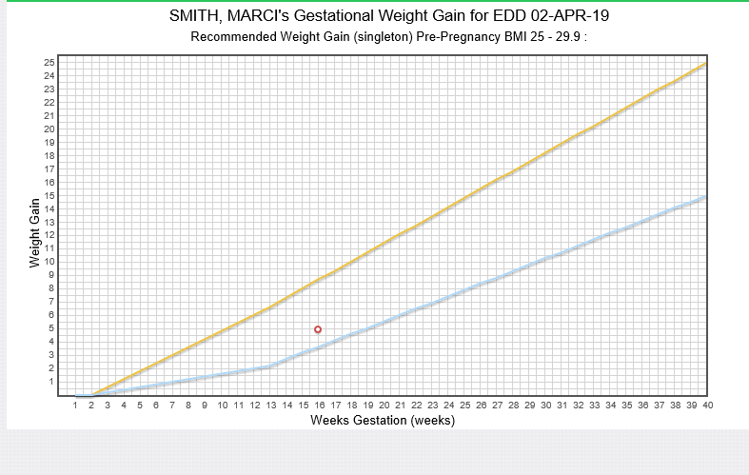
- How would you explain Marci’s pregnancy weight gain chart to her?
Possible responses:
• Doctors recommend a gradual increase in weight that falls between the blue and yellow lines. Today, this red circle indicates your weight at 16 weeks, which is well within the recommended weight gain range at this point in your pregnancy.
NOTE: One goal of prenatal nutritional counseling is to achieve a healthy rate of gain during pregnancy. The emphasis should be on selecting food choices of high nutritional quality, avoiding calorie-rich foods, and finding time to be active.
Scenario 2: Natasha is 31 weeks gestation with a singleton pregnancy. Her pre-pregnancy height is 5’8” and pre-pregnancy weight was 157 pounds, which is a pre-pregnancy BMI of 23.9. Her weight at 20 weeks gestation was 164 pounds. Her weight at 25 weeks gestation was 169 pounds. Her current weight is 173 pounds.
  - What is Natasha’s pre-pregnancy weight status based on her BMI?
Possible responses: b. Normal Weight
[Reference Module 2, Slide 12]
  - How much total weight is recommended for Natasha to gain throughout her pregnancy?
Correct response: 25-35 pounds
[Reference Module 2, Slide 12]
Review the pregnancy weight gain graph below for Natasha. Then answer the following questions.
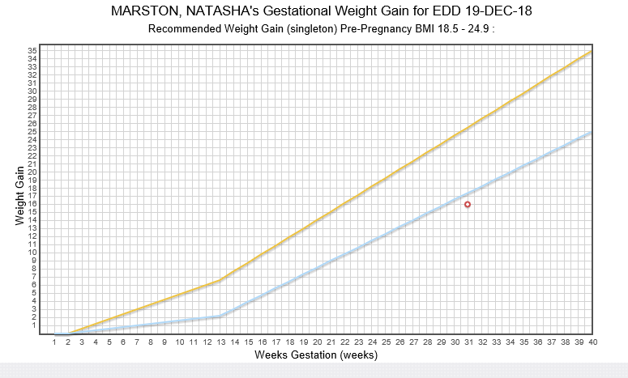

  - How would you explain the chart of Natasha’s weight gain during pregnancy to her?
Possible responses: (Module 2, slide 16)
• Doctors recommend a gradual increase in weight that falls between the blue and yellow lines. Today, this red circle indicates your weight at 31 weeks is here, just below the recommended range.
NOTE: One goal of prenatal nutritional counseling is to encourage participants to gain a healthy amount of weight during pregnancy. For the woman whose rate of gain is below the recommended, focus on encouraging food choices of high nutritional quality, healthy snacks between meals, and finding time to be active.
Scenario 3: Luis is a 13-month-old child with a recumbent length of 28 6/8 inches and recumbent weight of 21 lbs, 4 oz. His length-for-age plots at the 45th percentile. His weight-for-length plots at the 76th percentile.
- What is Luis’s weight status based on his weight-for-length?
Possible responses: a. Normal Weight
[Reference Module 2, Slide 12]
Review the growth chart below for Luis. Then answer the following question.
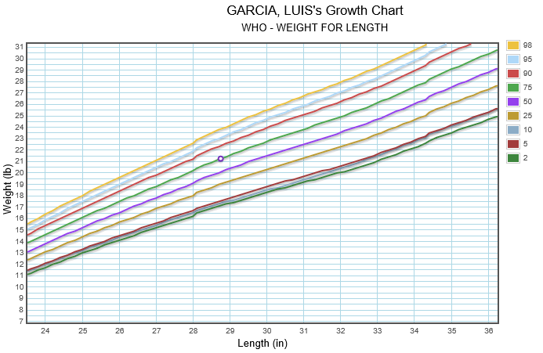
- How would you explain the chart for Luis’s growth to his caregiver?
Possible responses: (Module 2, slide 16)
• Doctors recommend a gradual increase in weight that falls between these lower and upper lines. Today, this purple circle indicates Luis’s weight-for-length is well within the recommended range for his growth.
Scenario 4: Elisa is a newborn infant with a recumbent length of 20 inches and a recumbent weight of 6 lbs, 6 oz. Her weight-for-length plots below the 2nd percentile.
- What is Elisa’s weight status based on her weight-for-length?
Possible responses:
a. Weight-for-length less than or equal to the 2nd percentile (MN Risk Code 121)
Review the growth chart below for Elisa. Then answer the following question.
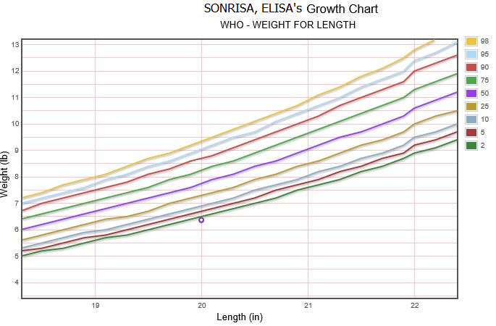
- How would you explain Elisa’s growth chart to her caregiver?
Possible responses: (Module 2, slide 16)
• The weight-for-length for most infants falls between the lower and upper lines on the graph. Today, this purple circle indicates Elisa’s weight-for-length is just below the 2nd percentile.

References- Complete Listing of Hyperlinks:
Anthropometrics Module (https://www.health.state.mn.us/training/cfh/wic/nutrition/anthropometric/story.html)
Anthropometric Manual (https://www.health.state.mn.us/docs/people/wic/localagency/training/nutrition/nst/anthro.pdf)
Exhibit 4-H: Checklist for Certification Observations (https://www.health.state.mn.us/docs/people/wic/localagency/program/mom/exhbts/ex4/4h.pdf)
WIC Risk Criteria (https://www.health.state.mn.us/people/wic/localagency/riskcodes/index.html)
WIC New Staff Training (https://www.health.state.mn.us/people/wic/localagency/training/nst.html)
Section 5.3 Nutrition Risk Assessment, Section 5.3.1 Anthropometric Data (https://www.health.state.mn.us/docs/people/wic/localagency/program/mom/chsctns/ch5/sctn5_3_1.pdf)
Precision of recumbent crown-heel length when using an infantometer (https://bmcpediatr.biomedcentral.com/articles/10.1186/s12887-016-0725-4)
HuBERT Clinic Training Modules (https://www.health.state.mn.us/people/wic/localagency/infosystem/hubert/training/2019/modules.html)
Growth & Weight Gain Grids (https://www.health.state.mn.us/training/cfh/wic/hubert/2019/grids/ggmodhtml5/index.html)
Minnesota Department of Health - WIC Program, 85 E 7th Place, PO BOX 64882, ST PAUL MN 55164-0882; 1-800-657-3942, health.wic@state.mn.us, www.health.state.mn.us; to obtain this information in a different format, call: 1-800-657-3942.
This institution is an equal opportunity provider.

