Anthropometrics Guidebook
  - UPDATED OCTOBER 2022
Trainee Edition

This guidebook was adapted from a training created by the Arizona WIC program.

Contents
Contents 2
What Will You Learn? 3
Items Needed for This Course 3
Recommended Time 3
Things to Remember 3
Anthropometrics Course Instructions 4
Important Notes About This Module 4
Module 1: Anthropometrics 5
Module 1 Competencies: 5
Module 1: Activity 1 5
Module 1: Activity 2 7
Module 1: Activity 3 7
Module 1: Activity 4 7
Module 1: Activity 5 8
Module 2: Practicing BMI and Interpreting Growth Charts 9
Module 2 Competencies: 9
Module 2: Activity 1 9
Module 2: Activity 2 9
References- A Complete Listing of Hyperlinks: 14

What Will You Learn?
Measuring length (or height) and weight is a simple and effective way to identify healthy growth patterns or to detect potential concerns for WIC participants. Accurate measures of length, height, and weight provide key information needed for a full nutrition assessment. Assessing growth and weight is an important step for helping WIC counselors determine if a participant has potential health risks.
After completing the Anthropometrics Module and this associated guidebook, you will be able to:
- Demonstrate proper techniques for taking accurate and precise measurements (Module 1)
- Avoid common errors when taking measurements (Module 1)
- Interpret and explain anthropometric charts to participants (Module 2)

Items Needed for This Course
- Pen or pencil
- Local Agency Referral List
- Access to Anthropometrics Module
- Access to the Anthropometrics Manual Minnesota WIC Program
- Access to the MN WIC Exhibit 4-H: Checklist for Certification Observations
- Access to the MN Allowed WIC Risk Criteria

Recommended Time
- Approximate time it takes to complete the Anthropometrics Module: One to two hours.
- Approximate time it takes to complete the activities in this Anthropometrics Guidebook and discuss with your preceptor: One to two hours.

Things to Remember
- This guidebook is yours to keep.
- You are encouraged to take notes, highlight, and write in this guidebook.
- As your preceptor chooses, you may work in a group or as an individual.
- Your preceptor has the answers to the questions posed in this guidebook.
- You are encouraged to ask your preceptor for help, ask questions about the information in the Anthropometrics Module, or ask any questions about additional topics related to anthropometrics.

Anthropometrics Course Instructions
- Locate the Anthropometrics Module on the MN WIC New Staff Training page.
Open and complete the Anthropometric module and the corresponding activities in this guidebook.
At your preceptor’s direction, complete the Anthropometrics Module and guidebook, either individually, with other trainees, or with your preceptor.
Complete the Anthropometrics post-test located on the MN WIC New Staff Training page.
Meet with your preceptor at their direction to discuss each module of the Anthropometrics training and the associated activities in this guidebook, either after each module or after all modules have been completed.

Important Notes About This Module
This Anthropometric Module was developed by the Arizona WIC Program and covers general anthropometric procedures and techniques. It provides a comprehensive review of requirements and is adequate Anthropometric Training for most MN WIC staff. For specific MN requirements and policy, refer to the Anthropometric Manual Minnesota WIC Program and Minnesota Operation Manual Section 5.3 Nutrition Risk Assessment, Section 5.3.1 Anthropometric Data. Variations between the Arizona WIC Program Anthropometric Module procedures and Minnesota WIC Program requirements are listed below.

- Minnesota WIC does NOT require second measurements. A single measurement of height/length or weight is adequate when care is taken to assure that proper measuring techniques are used. Whenever there is any doubt about the accuracy of a measurement, staff should re-measure.
- The Minnesota WIC Information System calculates Gestation-Adjusted Age for premature infants. For infants and children 0-24 months old who were born premature, the plot on the WHO graphs in the Minnesota WIC Information System correspond to their adjusted age and not their chronological age.
- For premature infants, the MN WIC Information system will show one plot on the Growth Grid, not two as stated in the module. If an infant is measured before reaching an adjusted age of 1 day, the measurement does not plot, as the graph does not allow for negative age values.
- The Minnesota Information System has “Premature Len/Age and Premature WT/Age grids. It is not recommended to use these grids to assess growth as is explained in HuBERT Clinic Training Modules- Growth & Weight Gain Grids .
- Specific anthropometric equipment requirements for the Minnesota WIC Program are described in the Anthropometric Manual Minnesota WIC Program.
- Minnesota WIC does not use Multi-Fetal Prenatal Weight Gain Grids, only Singleton Pregnancy girds are used. The CPA should take weight gain recommendations for multi-fetal pregnancies into consideration as they review the Prenatal Weight Gain Grid in the Minnesota WIC Information System.

Module 1: Anthropometrics

Module 1 Competencies:
- Trainees will be able to describe appropriate techniques for accurate measurement of length and weight for infants.
- Trainees will be able to offer guidance that helps participants prepare infants to be ready for measurement.
- Trainees will be able to guide the participant in steps to maintain the infant's comfort and position until accurate measurements are obtained.
- Trainees will be able to describe all of the steps necessary to accurately obtain length and weight measurements for infants.
- Trainees will be able to identify solutions for typical challenges when measuring infants (e.g., no spare diaper, tantrums, distractions, etc.).
- Trainees will be able to describe all of the steps and techniques necessary to accurately obtain standing height and weight measurements for children and adults.
- Trainees will be able to demonstrate accurate height and weight measurement of children
and adults.
- Trainees will be able to identify common measurement errors for infants, children, and adults.

Module 1: Activity 1
Instructions: For each question below, a descriptive term for collecting anthropometric data as listed in the MN WIC Exhibit 4-H: Checklist for Certification Observations is given. Answer the questions below by explaining the meaning for each term and how it affects measurement accuracy.
- Anthropometrics Tool: Scale is zero balanced between weights.
- What is meant by this phrase?
- How would not zeroing the scale shoes affect the new measurements?
- Anthropometrics Tool: Both Shoes and heavy clothing removed.
- What is meant by this phrase?
- How would shoes and heavy clothing affect the weight? How about the height?
- Anthropometrics Tool: Legs and hips straight, head facing up, both legs are used.
- What is meant by this phrase?
- How does pulling down only one leg or not straightening the legs affect length measurements?
- Anthropometrics Tool: Hats, braids, and hair accessories removed.
- What is meant by this phrase?
- How is length measurement affected when infants wear large hair accessories?
- Anthropometrics Tool: Clean, dry diaper, and t-shirt.
- What is meant by this phrase?
- How do soiled diapers affect weight measurement?
- Anthropometrics Tool: Participant positioned properly on the equipment.
- What is meant by this phrase?
- How would an improper position affect the final measurements.
- What type of infant scale will you use in your clinic?
- Infant balance beam scale
- Infant electronic scale
- Describe the difference between accuracy and precision in measuring.
- What would alert you to an incorrect weight measurement?
- What would alert you to an incorrect length measurement?
- Describe when recumbent length is still used with children up to 36 months old.

Module 1: Activity 2
Instructions: For each scenario below, offer an example of what you might say to help a participant understand what happens next.
- A participant is holding her baby and waiting for your instructions to weigh her infant.
- A participant is holding her baby and waiting for your instructions to measure her infant’s length.

Module 1: Activity 3
Instructions: For each question below, write out the best solution for the situation.
- A participant tells you they do not have a clean diaper to replace the infant’s wet diaper at the certification appointment.
- Infant is flailing wildly so that weight cannot be measured.

Module 1: Activity 4
Instructions: For each question below, write out the best solution for the situation.
- Which of the following child participants should be measured with height instead of recumbent length?
- A 23-month-old child who can stand with support
- A 22-month-old child who stands unassisted
- A 28-month-old child in a wheelchair who can stand with support
- None of the above
- Which of the following guidelines are correct for measuring children under 24 months?
- Ankles, hips, and shoulder blades aligned
- Without top hair adornment
- Without shoes
- Both legs are grasped and straightened for measurement (length)
- All of the above
- At what age do you begin measuring children’s standing height vertically?
- What type of scale will you use to weigh children/adults in your clinic?
- Electronic scale
- Balance beam scale
- For weight, what is the unit of measurement that appears on the child/adult scale in your clinic?
- For the child/adult scale, what is the unit of measurement you will enter for weight? (Module 1, Slide 12)
- Using your clinic’s reference sheet for converting tenths of a pound to ounces, what value would you enter if you measured a child’s weight to be 26.7 lbs?
- For the child/adult stadiometer, what is the unit of measurement you will enter for height?

Module 1: Activity 5
Instructions: For each activity below, enlist the help of your preceptor or a coworker (if possible) to help you practice taking anthropometric measurements.
  - Take a precise and accurate weight measurement of a fellow staff member (or yourself if a coworker is not available). Document this number.
Next, repeat the same measurement while wearing shoes and removable outer clothing (additional layers, if applicable). Document this number.
What is the numerical difference between the first and second weight measurements?
  - Take a precise and accurate weight measurement of a fellow staff member (or yourself if a coworker is not available). Document this number.
Next, repeat the same measurement while positioning the person’s body towards the edge of the scale rather than in the center of the scale. Document this number.
What is the numerical difference between the first and second weight measurements?
  - Name as many common errors as possible in measuring recumbent length.
  - Name as many common errors as possible in measuring height for children and adults.
  - How can a height measurement of a child or woman be affected if their head moves downward so their chin is near their chest?
  - How can the difference between an accurate and an inaccurate measurement potentially affect WIC data?

Module 2: Practicing BMI and Interpreting Growth Charts

Module 2 Competencies:
- Trainees will be able to appropriately explain children’s growth patterns to caregivers.
- Trainees will be able to explain when new measurements are required to be entered in the WIC information system.
- Trainees will be able to interpret and explain prenatal weight gain charts.

Module 2: Activity 1
Instructions: Review the growth measurements for the three children described below.
For each child, use the Allowed WIC Risk Criteria to determine if the growth pattern indicates one of the following:
- normal weight
- BMI at or below the 5th percentile (WIC Code 103)
- BMI between the 5th and 10th percentile (WIC Code 103)
- BMI at or above the 85th percentile but below the 95th percentile (WIC Code 114)
- BMI at or above the 95th percentile (WIC Code 113)
- A 3 y.o. male with a BMI at the 97th percentile.
- A 2 y.o. female with a BMI at the 9th percentile.
- A 4 y.o. female with a BMI at the 90th percentile.
- Explain the circumstances when new measurements are to be entered into the WIC Information System.

Module 2: Activity 2
Instructions: Review the scenarios for pregnant and child participants described below. Then answer the following questions.
Scenario 1: Marci is 16 weeks gestation with a singleton pregnancy. Her pre-pregnancy height is 5’2” and pre-pregnancy weight was 150 pounds, which is a pre-pregnancy BMI of 27.4. Her weight at 12 weeks gestation was 153 pounds. Her current weight is 155 pounds.
- What is Marci’s pre-pregnancy weight status based on her BMI?
- How much total weight is recommended for Marci to gain throughout her pregnancy based upon her pre-pregnancy BMI?
Review the pregnancy weight gain graph below for Marci. Then answer the following questions.
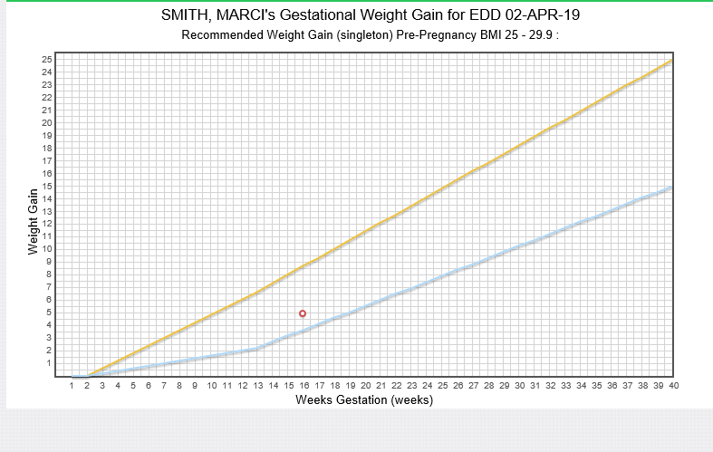
- How would you explain Marci’s pregnancy weight gain chart to her?
Scenario 2: Natasha is 31 weeks gestation with a singleton pregnancy. Her pre-pregnancy height is 5’8” and pre-pregnancy weight was 157 pounds, which is a pre-pregnancy BMI of 23.9. Her weight at 20 weeks gestation was 164 pounds. Her weight at 25 weeks gestation was 169 pounds. Her current weight is 173 pounds.
  - What is Natasha’s pre-pregnancy weight status based on her BMI?
  - How much total weight is recommended for Natasha to gain throughout her pregnancy?
Review the pregnancy weight gain graph below for Natasha. Then answer the following questions.
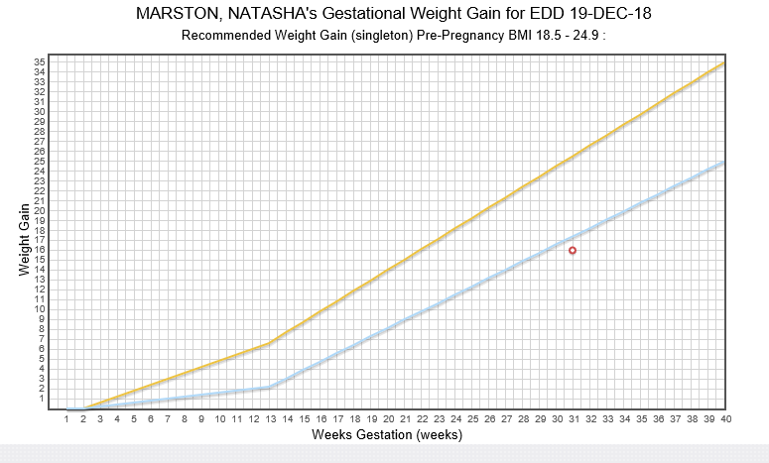

  - How would you explain the chart of Natasha’s weight gain during pregnancy to her?
Scenario 3: Luis is a 13-month-old child with a recumbent length of 28 6/8 inches and recumbent weight of 21 lbs, 4 oz. His length-for-age plots at the 45th percentile. His weight-for-length plots at the 76th percentile.
- What is Luis’s weight status based on his weight-for-length?
Review the growth chart below for Luis. Then answer the following question.
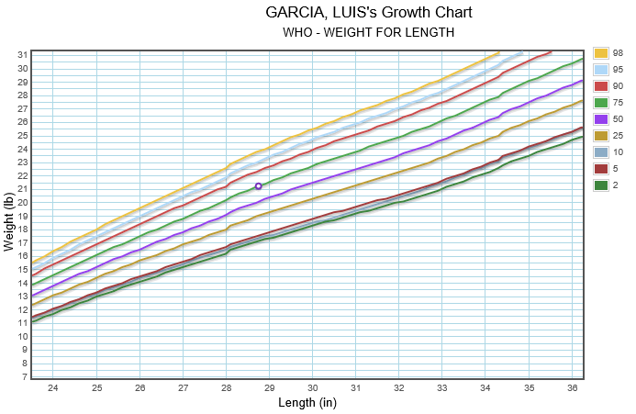
- How would you explain the chart for Luis’s growth to his caregiver?
Scenario 4: Elisa is a newborn infant with a recumbent length of 20 inches and a recumbent weight of 6 lbs, 6 oz. Her weight-for-length plots below the 2nd percentile.
- What is Elisa’s weight status based on her weight-for-length?
Review the growth chart below for Elisa. Then answer the following question.
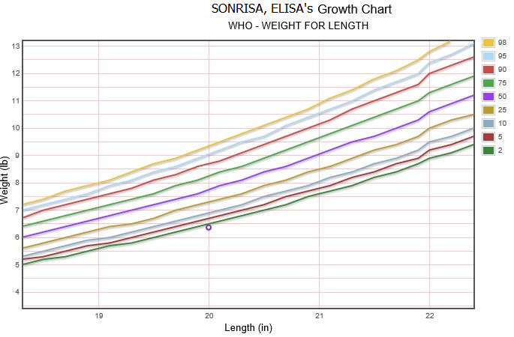
- How would you explain Elisa’s growth chart to her caregiver?

References- Complete Listing of Hyperlinks:
Anthropometrics Module (https://www.health.state.mn.us/training/cfh/wic/nutrition/anthropometric/story.html)
Anthropometrics Manual Minnesota WIC Program (https://www.health.state.mn.us/docs/people/wic/localagency/training/nutrition/nst/anthro.pdf)
Exhibit 4-H: Checklist for Certification Observations (https://www.health.state.mn.us/docs/people/wic/localagency/program/mom/exhbts/ex4/4h.pdf)
WIC Risk Criteria (https://www.health.state.mn.us/people/wic/localagency/riskcodes/index.html)
WIC New Staff Training (https://www.health.state.mn.us/people/wic/localagency/training/nst.html)
Section 5.3 Nutrition Risk Assessment, Section 5.3.1 Anthropometric Data (https://www.health.state.mn.us/docs/people/wic/localagency/program/mom/chsctns/ch5/sctn5_3_1.pdf)
HuBERT Clinic Training Module (https://www.health.state.mn.us/people/wic/localagency/infosystem/hubert/training/2019/modules.html)
Growth & Weight Gain Grids Module (https://www.health.state.mn.us/training/cfh/wic/hubert/2019/grids/ggmodhtml5/index.html)
Minnesota Department of Health - WIC Program, 85 E 7th Place, PO BOX 64882, ST PAUL MN 55164-0882; 1-800-657-3942, health.wic@state.mn.us, www.health.state.mn.us; to obtain this information in a different format, call: 1-800-657-3942.
This institution is an equal opportunity provider.

