Inactivated Influenza Vaccine (IIV) Vaccine Protocol
  - vaccine protocol for Children Age 6 Months Through 8 Years
Document reviewed and updated: August 31, 2023

Condition for protocol
To reduce incidence of morbidity and mortality of influenza disease in children age 6 months through 8 years.

Policy of protocol
The nurse will implement this protocol for influenza vaccination.

Condition-specific criteria and prescribed actions
Delete this entire paragraph before printing/signing protocol.
[Instructions for persons adopting these protocols: The table below lists indication, contraindication, and precaution criteria and suggested prescribed actions that are necessary to implement the vaccine protocol. The prescribed actions include examples shown in brackets but may not suit your institution’s clinical situation and may not include all possible actions. A licensed prescriber must review the criteria and actions and determine the appropriate prescribing action.]
Indications
Criteria | Prescribed action
Child is currently healthy and age 6 months to 9 years | Proceed to vaccinate if meets remaining criteria.
Child is less than 6 months of age. | Do not vaccinate.  [Instruct parent to return when child turns age 6 months]  [Encourage parents to get vaccinated.]
Child is 9 years or older and healthy. | Follow the influenza protocol for persons 9 years and older.
Child is currently healthy but has a chronic medical condition. | Proceed to vaccinate if meets remaining criteria.
Child is currently healthy and age 6 months to 9 years | Proceed to vaccinate if meets remaining criteria.
Contraindications
Criteria | Prescribed action
Child had a severe allergic reaction (anaphylaxis) to a previous dose of influenza vaccine. | Do not vaccinate; _____________________
Child has a severe allergic reaction (anaphylaxis) to a non-egg component of currently available IIV product. | Do not vaccinate; _____________________  [If allergy is related to a component that is not in another vaccine product on hand use that vaccine product, otherwise refer to another vaccinator.]
Precautions
Criteria | Prescribed action
Child has a mild illness defined as temperature less than ____°F/°C with symptoms such as: [to be determined by medical prescriber] | Proceed to vaccinate.
Child has an acute moderate to severe illness defined as temperature ____°F/°C or higher with symptoms such as: [to be determined by medical prescriber] | Defer vaccination and ____________________________  [to be determined by medical prescriber]
Child has a severe allergic reaction (anaphylaxis) to eggs. | [Proceed to vaccinate.]  [Offer ccIIV4 or RIV4 if available or refer Primary Care Provider.]
Child has a history of Guillain-Barré syndrome within 6 weeks of a previous influenza vaccination. | [Refer to primary care provider for determination of risk and benefit of influenza vaccination]  [Proceed to vaccinate after discussing risk and benefit of influenza vaccination and GBS.]

Prescription
Give any of the following products depending upon which is available and if age appropriate.
Product* | Dose | Route | Age Indication
Afluria, quadrivalent (IIV4) | 0.25 mL | IM | 6 months through 35 months
Afluria, quadrivalent (IIV4) | 0.5 mL | IM | 36 months and older
Fluarix, quadrivalent (IIV4) | 0.5 mL | IM | 6 months and older
FluLaval, quadrivalent (IIV4) | 0.5 mL | IM | 6 months and older
Fluzone, quadrivalent (IIV4) | 0.25 mL or 0.5 mL | IM | 6 months through 35 months
Fluzone, quadrivalent (IIV4) | 0.5 mL | IM | 6 months and older
Flucelvax, cell culture, quadrivalent (ccIIV4) | 0.5 mL | IM | 6 months and older
* In order to assist in delineating specific product indications, product names are used, but are not a product endorsement.
Follow the algorithm on the next page in order to determine which child age 6 months through 8 years needs a second dose of influenza vaccine.
- When indicated, give the second dose at least 4 weeks after the first dose.

Medical emergency or anaphylaxis
Follow pre-established agency protocol for anaphylaxis.

Question or concerns
Insert overseeing medical consultant’s information below and delete this sentence before printing/signing.
In the event of questions or concerns call (insert name) at (insert phone number).
This protocol shall remain in effect until rescinded.
Name of prescriber (please print):
Prescriber signature:
Date:
Influenza vaccine dosing algorithm for children 6 months through 8* years old, 2023-24 influenza vaccination season
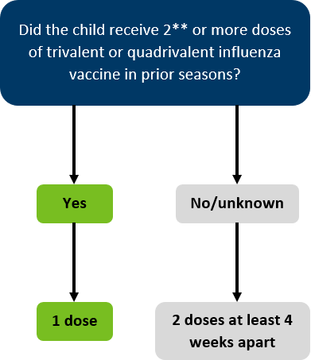
*For children aged 8 years who require 2 doses of vaccine, both doses should be administered even if the child turns age 9 years between receipt of dose 1 and dose 2.
**The two doses do not need to have been received during the same or consecutive seasons.

